The Build;

Main inspiration – Whipper Trebuchet by Tom Stanton

## Frame 1.0

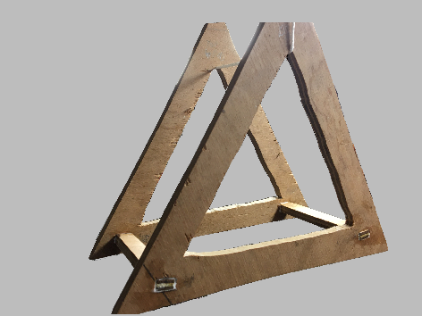The frame marked the beginning of my trebuchet project so it was good for learning how to use new tools that I hadn’t got much experience with for example the fret saw which I used to cut out the interior triangles.

The frame is made from two outlined equilateral triangles of outside length varying between 25 and 27cm on some edges which is a testament to the terrible tolerance I could hold at the start of this project. The two triangles are held together with two pieces which were sanded down to wedges on both sides then hammered and glued into the rectangles cut out of the triangles.

This frame was very rigid which surprised me as I thought the thinness of the connecting pieces would lead to a lot of movement under a bit of stress but due to the properties of plywood it did not.

## Main arm 1.0

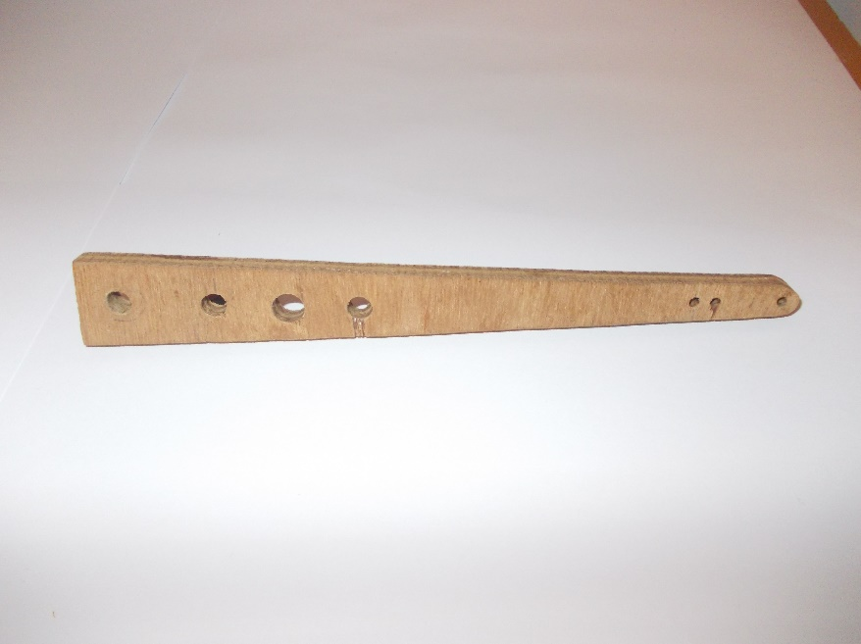Next came the main arm which I did not make to any set size other than a reasonable amount shorter than the frame so that it could rotate 360 degrees without hitting the frame. In hindsight I can recognise this as a big mistake as I had not taken into account the length of the sling which I have called ‘the frame interference problem’ and have discussed in detail later on.

## Secondary arm 1.0

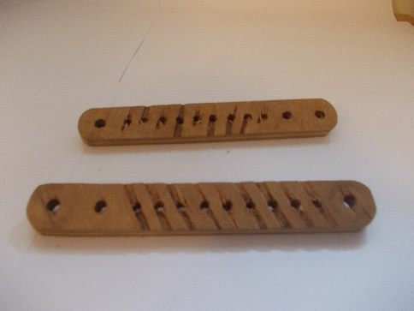When I first made the secondary arms, they only had the holes on either end however I later added more holes incrementing by 1cm so that I could vary the length of the secondary arm to conduct my experiments. This did not work however as I have discussed later due to something I have named ‘the short secondary arm setting problem’.

## Main axle 1.0

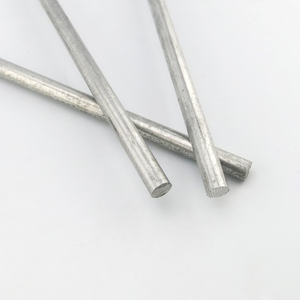I have no actual image for this part but it looked very similar to this.

I had planned to thread both ends of the rod so that I could then use a nut on both sides to hold the axle in the frame.

Unfortunately, the rod was not a common diameter so I had to use the closest sized die I had which failed catastrophically by simply ripping the soft metal to shreds and leaving the end I tried to thread simply half the diameter it used to be. This caused me to abandon this idea.

## Main axle 2.0

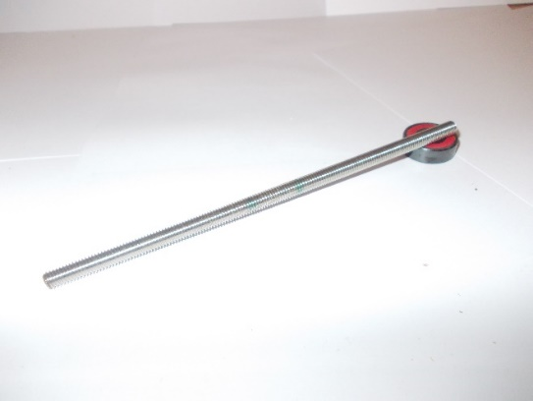It was at this point that a someone suggested to me that I used already threaded bar of very similar size. This solved the issue of threading and so I continued with it until it caused ‘the too many nuts problem’ and also ‘the bearing stability problem’.

## The bearings 1.0

These are some of the bearing I acquired from a £3 fidget spinner I’ve had for a long time. The fidget spinner had four in total bearings which will come in handy later.

## The bearing housings 1.0

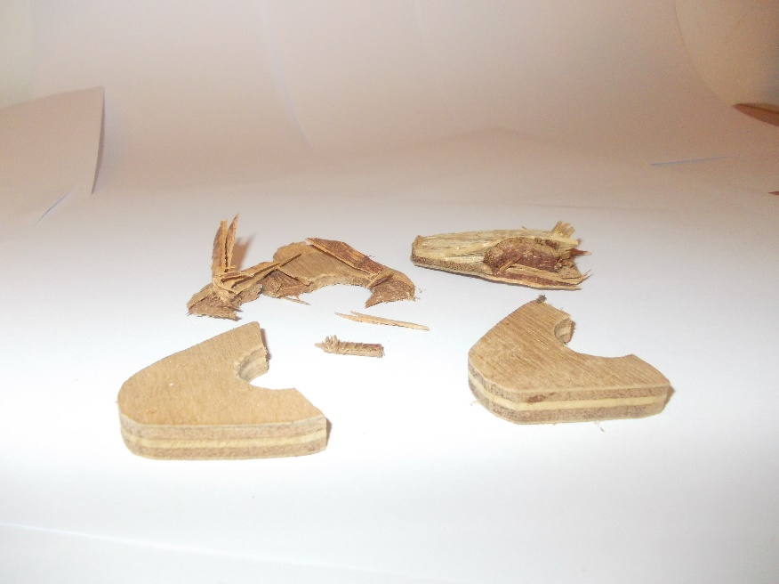This is all that’s left of these parts. They were originally a rounded diamond shape with a 20mm hole taken out in the centre where I planned to put the bearings. The bearings I had had an outside diameter of 22mm. That is the standard skate bearing size which is probably why cheap fidget spinners use them as they are most likely mass produced from all the demand skateboarders generate.

I then proceeded to file out the holes into just smaller than the bearings so that later I could fix the bearings into the hole with a bit of force. Unfortunately, it is almost impossible to file everywhere in the hole the same amount and so the hole became slightly less circular and high-spots were created but I just ignored that and continued anyway.

After much sanding and filing I was happy enough and decided to put the bearing into the holes. The holes were, by design, slightly too small for the bearing and so to insert then I hammered them with a mallet. After much whacking the bearings were finally in place, however, when I tried spinning the bearings, they both now were extremely tough to turn which is an extremely bad sign for a bearing. The bearings were fine before I put them into their housings and so the process of hammering in the bearing must have damaged them enough on the inside so that they were now pretty much useless. It also occurred to me that the non-circularity of the holes might also have placed an unequal amount of force on the bearing which also could have damaged the bearings. Finally, another thing I realised after this is that this is probably the reason most bearing are pressed into tight fits as it is much more gentle comparatively and also lets you apply and even force around the circumference of the bearing make sure it goes in straight the whole way.

It was at this point that I found a 22m hole saw and so I decided to start over and rather than knock them back out I cut one out with a saw and crushed the other out with a vice.

## The bearing housings 2.0

These were the same shape as the bearing housings 1.0 however instead the holes were made with a 22mm hole saw. The only 22mm hole saw I had though was quite well used and some of the teeth were slightly bent and so the hole ended up being about 0.4mm larger than 22mm. This meant that the bearings were not a snug fit and would fall out. To fix this I made the bearings 2.0

## The bearings 2.0

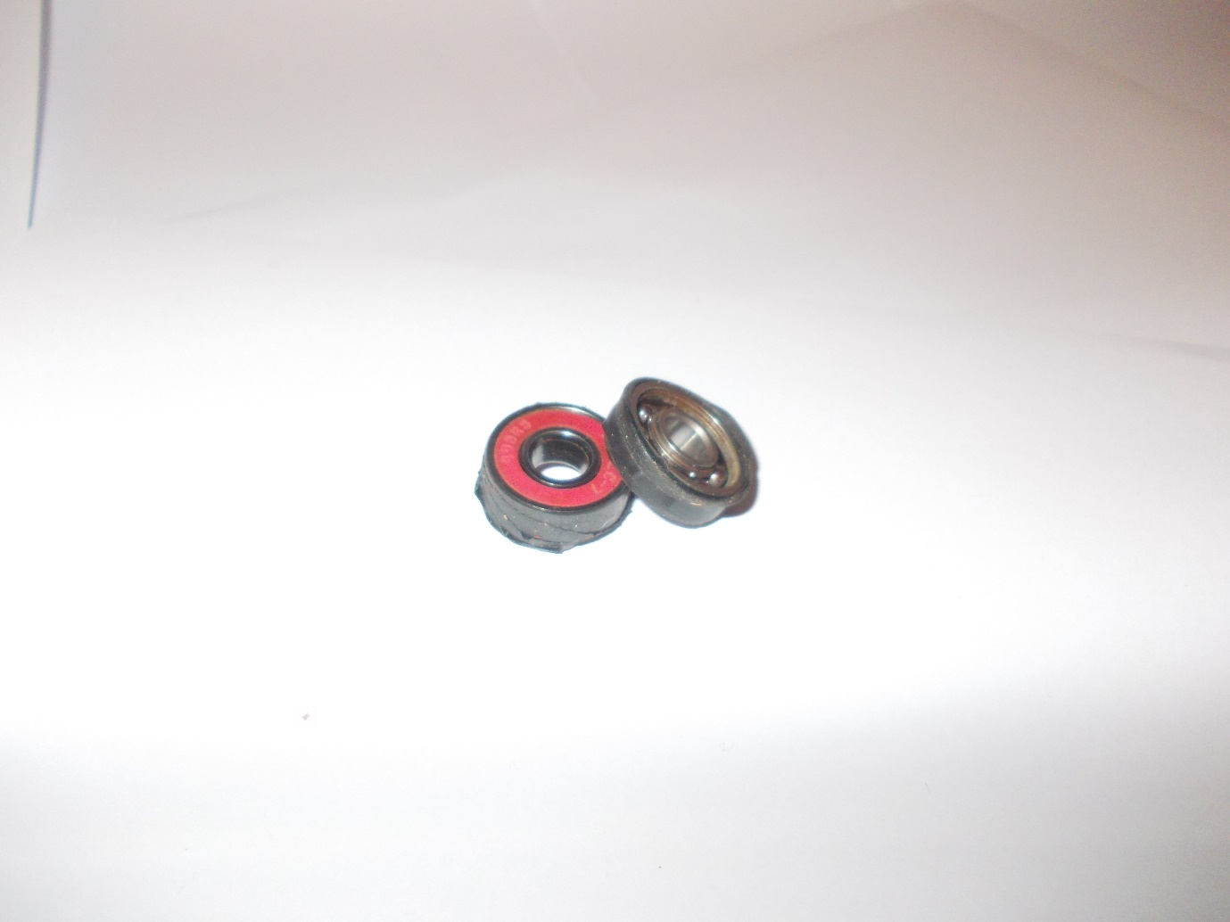These bearing are from the same fidget spinner as the other two, the one on the right doesn’t have protective covers as it used to be the central bearing for the fidget spinner and so had to hold the centre pieces that you would hold onto, but it should work just fine for my purposes.

The difference is that I wrapped the outside of the bearings in about 15cm of electrical tape. This made up the gap between them and the housing for a very nice tight fit that I could push in by hand.

## The bearing stability problem

It just so happened that the current axle I was using, main axle 2.0, was 6mm threaded rod and also the only threaded rod I had. On the other hand the inside diameter of the bearings was 8mm which was absolutely terrible and the whole assembly would turn up to 20° either side of perpendicular from the main axle even with two fixed and separated bearings whose design was partially to increase stability on the main axle rather than just a single bearing which would have been even less stable.

The first way I thought of solving this problem was to simply wrap the parts of the rods where the bearing would sit in electrical tape similarly to how I fit the bearings into their housings. However, when I tried this the electrical tape would not stick to the threaded rod at all and I couldn’t get it to work at all so I abandoned that idea.

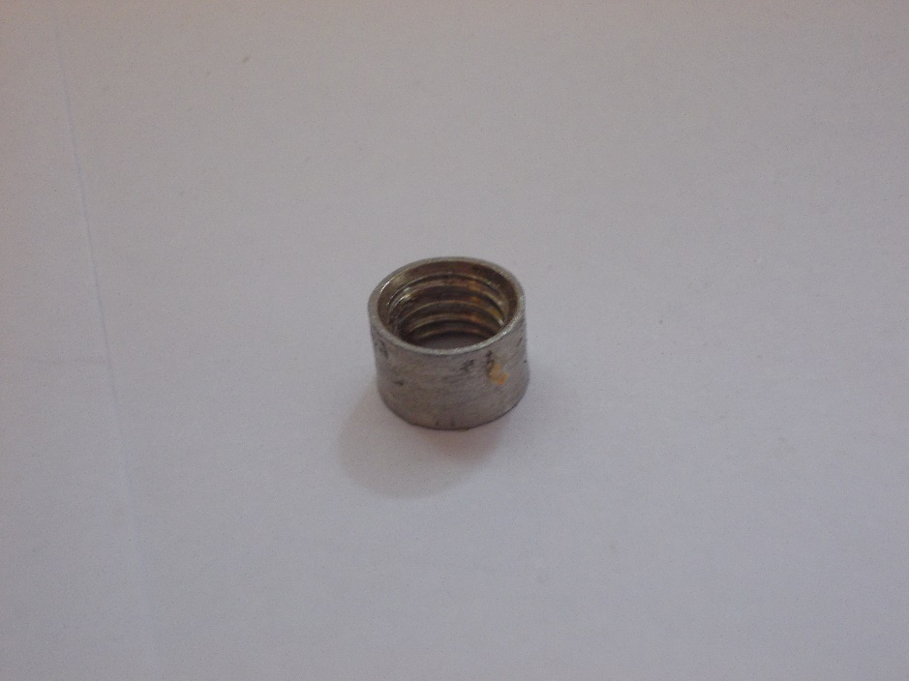My second idea was to take two nuts that fit onto the main axle and then to round them off to exactly 8mm so then they could be fitted inside the bearing and so then they could be fixed to the main axle very snugly.

To make the hexagonal nuts round I put them both on a bolt and then put that bolt into the lathe and slowly worked down to the perfect diameter.

Unfortunately, this then led into two more problems.

## The too many nuts problem

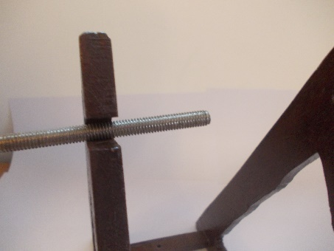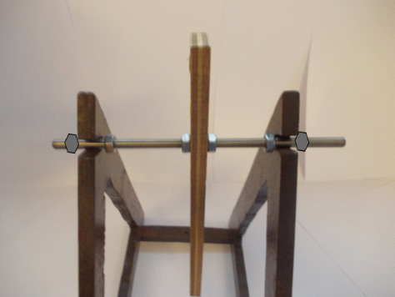I counted 6 nut and 6 washers that I had to put on in a specific order as well as the specially made round nuts while slowly pushing in the threaded rod through the holes in the frame which was very awkward to do. This was incredibly tedious especially when wanted to quickly test the trebuchet before and after making lots of small changes which would have taken too much time to be reasonable.

I didn’t completely solve this problem until later however I made it a lot easier to live with by just cutting a notch from the outside into the holes that was slightly smaller than the holes themselves so to put the axle into the frame I simply had to use a bit of force to push in the axle and the holes would then clamp onto it. This meant I didn’t have to assemble the main axle with all the nuts in really specific order and could assemble it outside the frame and then just push it into place. This did sacrifice a bit of theoretical structural integrity however I did not notice any difference in the rigidity before and after cutting the slots which is probably due to the general strength of plywood. This problem was then solved completely with the next part.

## Main axle 3.0

Despite the change I made to the frame to make it easier to assemble the trebuchet it was still taking me too long and so I abandoned the wrong threaded axle idea for a simple 8mm slightly rusty rod that I harvested from my father’s scrap metal pile. It was also bent on one end into a hook so I cut that end of and then lightly sanded the whole thing too make it smoother.

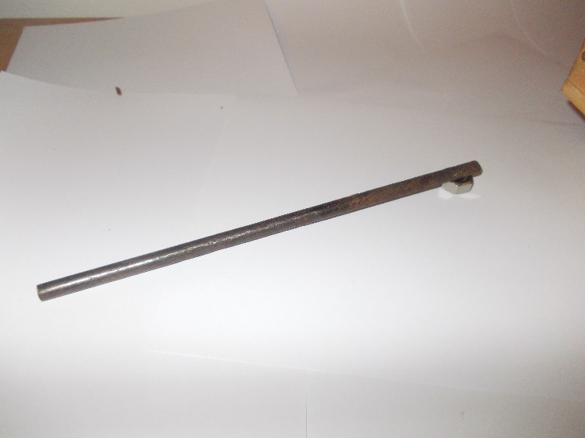My expectations were that it would either be impossible to get the bearing on and along the rod or too easy and unstable, so I was completely blown away when this random rusty roughly 8mm rod which took me about 30 seconds to find in a large scrap pile fit so darn well. It took a bit of wiggling to get them along the rod and they could only fit on the side I sanded more but it took me a fraction of the time it took me to assemble the previous main axle. The axle was also now held in the frame completely by clamping effect created by the notches to the holes in the frame. The bearing assembly would sometimes move along the axle so it would need to be slid back to the centre every now and then.

This didn’t look that great being rusty and all, so I ordered some stainless; rod.

## The firing pin 1.0

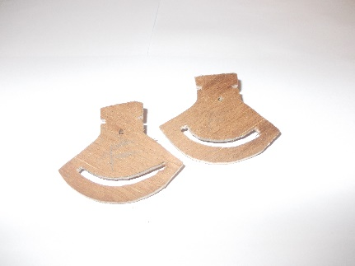When designing my firing pin from the get go I decided I wanted to make it adjustable so that I could tweak the release angle later in my experiments. I made two pizza like pieces and wanted to join them with a gap so they could go on the end of the main arm, however, because I had to make it out much smaller plywood (3.5mm), every time I tried making another piece to join them it would de-laminate or just simply snap. This meant I had to scrap the whole idea of making such a small and intricate part out of wood and instead make it out of metal.

## The firing pin 2.0

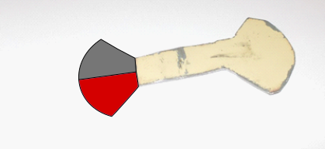This was my first time in a long while working with steel sheet metal so I had my father watch me use the angle grinder to start off with, which was what I used to roughly cut it out.

The idea for this part was instead of making two separate plates and then join them, because I was using metal now, I could instead make the whole thing in one piece and then bend it 180 degrees at the centre so that everything lined up.

Sadly, I decided to freehand the marking out and then also overcut my lines so I gave up actually using and decided to practice grinding on it. then over grind it so it was terribly uneven in both lines of supposed reflection. So, I chose the best-looking portion (shown in red) and cut it off and used it as a stencil for both parts of both ends in 3.0.

## The firing pin 3.0

Using the stencil from the previous iteration I, with much more practise, cut out the much neater drawing and then cut out the arc of a circle cantered at a specific point. I cut out this slot by first drilling holes along the slot line and then connecting the drill holes with a Dremel.

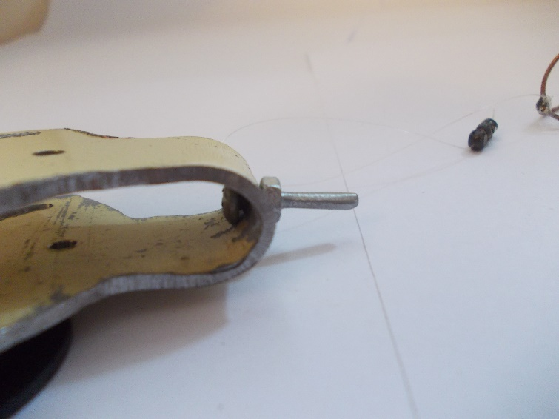The bending went very well and the slots lined up very well which is why I was so happy that I made this out of metal as it is easy to re-align if necessary. I then drilled the centre of the circle that the arc was marked out from. I did this after bending so I could do both holes at once and therefore they would be perfectly aligned.

For the pin itself I first drilled a 3mm hole then through it I put a 3mm flathead bolt and fixed it in place with a nut. I then sanded the rest of the bolt smooth from 60grit all the way to 1200grit to stop the sling loop getting caught in the threads and messing up the release angle.

## The projectile 1.0

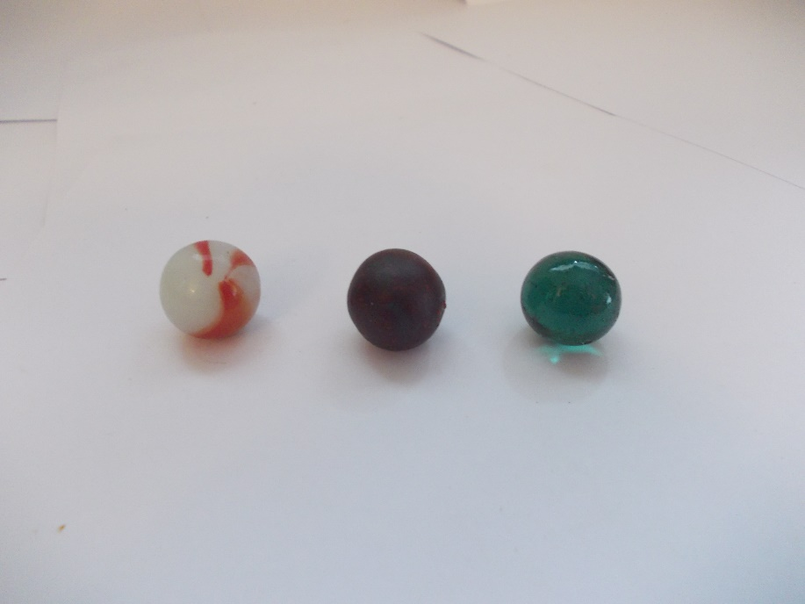The first spherical thing that came into my mind when I look at the height of my trebuchet (at the time it was 30cm tall was a marble, I also had a lot of them so that was what I used. The one on the left is slightly larger than the two on the left which were the same before I painted the middle one with bright pink so it would show up better on video however it backfired and ended up just making it darker. I eventually decided on the right two marbles as they happened to fit the carriage, I had made next.

## The sling and carriage 1.0

Whenever I have ever seen a trebuchet, I have always seen fabric pouches of some kind. This is probably because without both ends of the rope that connect to it under tension it would easily give way and release the projectile. I looked for a bit of fabric that I could use, however, I couldn’t really find any so I instead got the idea to make a sort of skeleton carriage out of copper wire which I could solder together. This also had the large advantage I thought, that it would have much less cross-sectional area and so much less air resistance which would let the trebuchet perform better.

It took three or four full attempts, a helpful crocodile to hold the wire while I worked on it and the discovery of soldering flux (used to stop oxides forming on the metal when it heats up so that it can better join to the solder) before I finally had a nicely sized carriage for the marble I was using.

For the sling itself I almost immediately though of fishing line as I had a lot of it and it had a very small diameter which would also mean less air resistance. The line I found was 0.2mm and was rated up to 3.90kg ±0.01kg which I assume means the maximum mass it could hold in earth’s gravity. I can do some really cool calculations using this number which you can see in the main document.

## The main axle 4.0

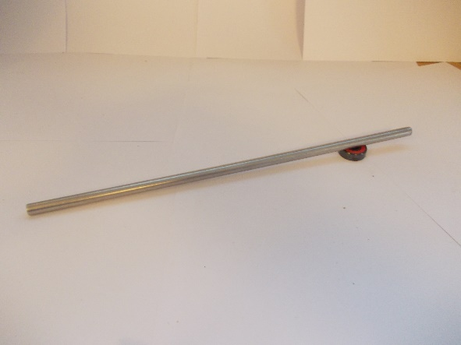When ordering the stainless rod that would become the main axle, I mistakenly thought the interior diameter of the bearings was 6mm when in fact it was 8mm and I had confused it for the diameter of the bolts I was using somehow. Nevertheless, the next day I measured the inside diameter of the bearing which I should have done first from the start but alas no one is perfect. After then ordering the correct diameter rod the 8mm rod arrived three days later with no sign of the 6mm rod despite the fact I ordered it from the same place a day earlier but hey, who am I to complain. It surprising took a week and a half before the 6mm rod arrived.

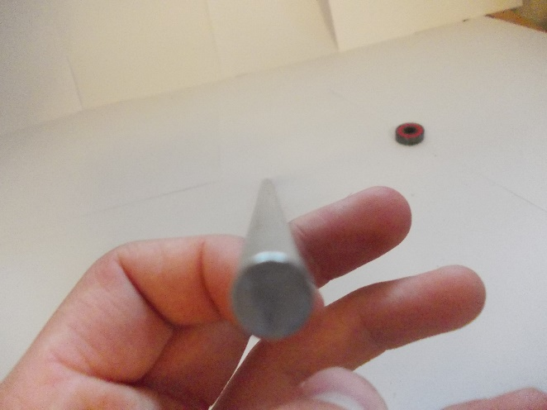This new rod was exactly 8mm when I measured it with a micrometre and the bearings would only go on it after I sanded a chamfer on one end and oiled the rod to reduce friction and allow them to slide along the stainless rod. There was a very little amount of play in the bearing but I’m pretty sure it came from the bearing itself as the inner part of the bearing did not move at all.

## The counterweight 1.0

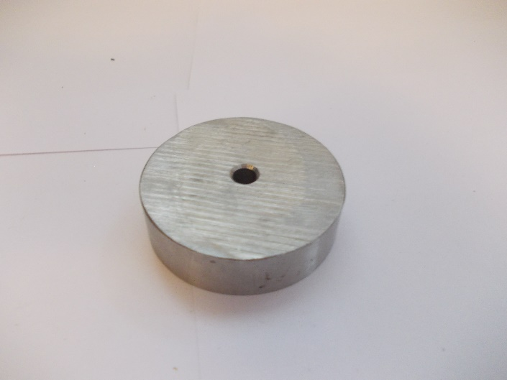The last piece needed to complete the main mechanism of the trebuchet was the counterweight. I did not have any weights with a hole in the centre with which I could fix it on the secondary arms so I resolved to make my own counterweight out of some spare steel bar stock. I cut the end of a much longer piece of 5.1cm diameter bar stock with a width of 1.5cm and then drilled a hole in the centre and then countersunk it for no other practical reason than that it was very satisfying.

It had a mass of 231g which felt and looked like a very suitable mass as it caused the trebuchet to whip just like its name suggests but also didn’t look like it was too violent that it would damage the trebuchet. There was however a problem caused by this counterweight I have called ‘The shaky secondary arm problem.’

## The shaky secondary arm problem.

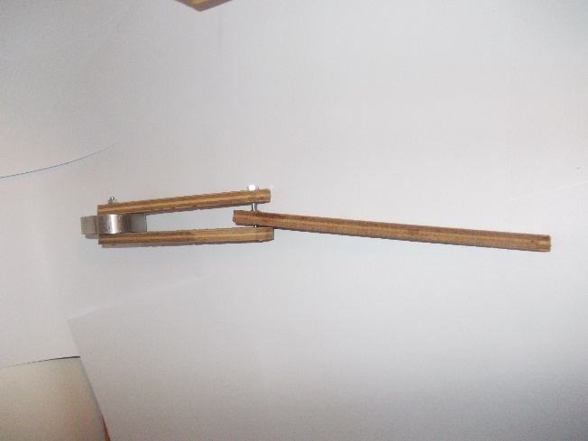This problem was caused by the difference in thickness of the main arm and the counterweight. The problem can be greatly reduced in magnitude by tightening the nut holding the secondary arms to the main arm so it slightly bends the secondary arms so they run closer to the main arm and there is much less play in the connection. This is however much less viable for shorter secondary arm settings as the plywood does not bend as much when it is shorter.

Out of all of the problems I have and will have with my trebuchet I would consider this one the least trouble but instead just a bit of an irritation. This is because it did not in any notable way effect the actual practical performance of the trebuchet but instead just look a bit flimsy and unprofessional.

And so, I decided to make the counterweight 2.0.

## The counterweight 2.0

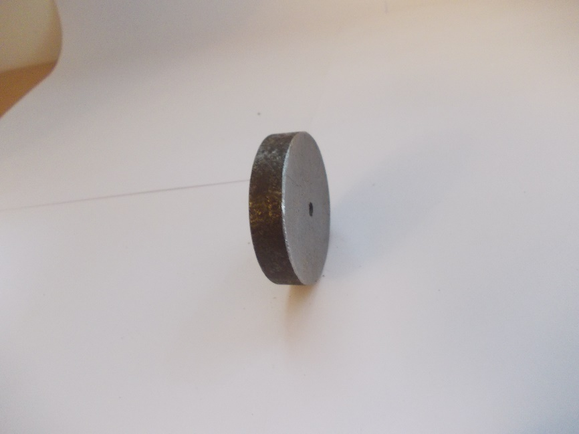This counterweight was almost identical to the first and was made from the same material and had the same diameter. The only differences being that it I cut it slightly thinner at 1.1cm to solve ‘the shaky secondary arm problem.’

When I tried it out and tested it on the trebuchet, although it solved one issue it also created a whole new one. This new counterweight was not heavy enough. It would not cause the trebuchet to “whip” like it was supposed to despite only being 63g lighter! This meant I would mainly revert back to the counterweight 1.0 for all actual testing purposes.

## The main arm 2.0

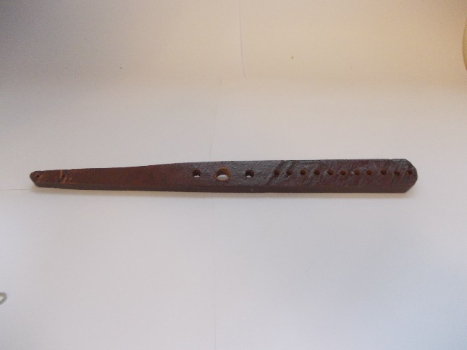I now needed the ability to vary the ratio the length from the main fulcrum to the secondary fulcrum so that I could carry out experiments to test the effect of the arm ratios to performance of the trebuchet which was my main objective for the whole project. To do this I simply used the first main arm as a stencil for the second but cut it longer on one end. I then marked out then drilled multiple holes exactly that went up in 1cm increments from the main axle.

This meant I now had multiple choice for the distance between the main and second fulcrums for the trebuchet.

## The weight collision problem

It was at this point that I started adding all the holes to the secondary arms so that I could vary the distance between the counterweight and the secondary fulcrum. While adding those holes I realised a very real problem. For certain settings on both the secondary and main arms the counterweight would now collide with the main arm and stop full rotation. More specifically when the distance between the secondary fulcrum and the end of the main arm is larger than the distance from the secondary fulcrum to the counterweight bolt minus the radius of the counterweight.

One of the ways that I thought of to solve this problem for every combination of settings is to have a different main arm for every hole setting.

The big disadvantage of this solution is that it would take a lot of time and effort to make as many different arms as I wanted settings. This is because it is not a very nice shape as one end is sloped down to the firing pin end, but also because there are a lot of precise holes in it to hole the firing pin and the bearing housings which would be time intensive to drill so many times.

The second solution I thought of was to once I had finished testing all the possible settings for the furthest setting to simply chop off that hole, which is very easy and quick, and then test all the possibilities for the next hole and then repeat until all data had been gathered for every setting.

The only disadvantage of this solution is that after taking all the data if I wanted to go back to redo some settings, I would have to make another main arm.

I decided to go with the second solution.

## The short secondary arm setting problem

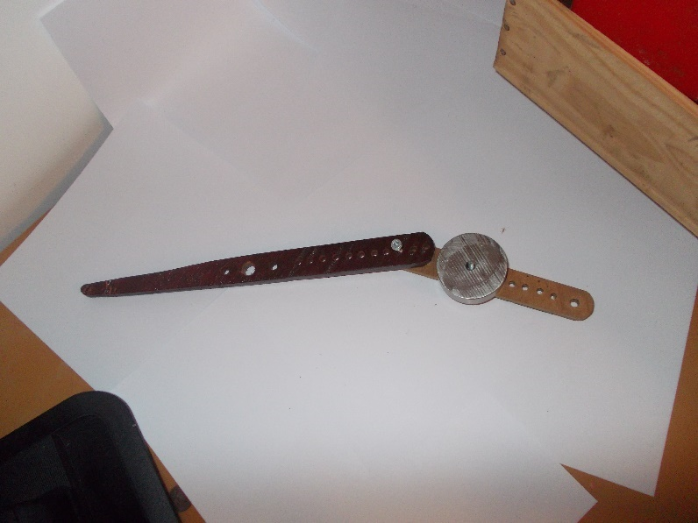I realised at about the same time as I realised the previous problem that shorter secondary arm settings there would be a lot spare wood material poking out past the counterweight and would affect the location of the centre of mass quite significantly and could lead to the rotation of the secondary arm prior of after it would normally have rotated around the secondary fulcrum which would affect the moment force on the main arm at different phases of firing. This could greatly skew the data I would take which would be very bad for my experiments.

Unfortunately, I could not use the same solution as the previous problem as it would fail due to it creating a paradox and I will try to explain it as best I can. Consider this: To get the maximum main arm to minimum secondary arm setting I would have had to have chopped off all but the last hole on the secondary arm yet still have every hole including the last on the main arm. But, to get the maximum secondary arm to minimum main arm setting I would need to have cut off all other holes on the main arm which means I will have to have already done the previous setting but to get the previous setting all the holes bar one on the secondary arms must have been removed and unless I can find a way to poke a hole in reality this is an unsolvable paradox.

Instead to solve this I decided to create different secondary arms for every single setting.

## Secondary arms 2.0

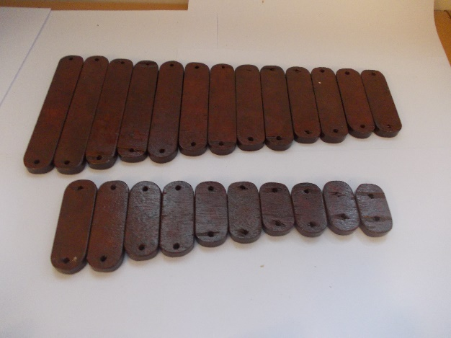These arms were the same width as the previous ones (2.5cm) there were two for every size from 2cm all the way to 13cm incrementing by 1cm so 24 pieces in total. Fortunately, they were a very easy to produce in mass as I simply cut long strips of 2.5cm wide plywood and then cut those long strips down into the correct lengths. I then rounded the corners on them with the disc sander and they were complete.

And yes, I do notice that there are an odd number of pieces in the photo and I can only conclude that I have lost a piece and will have to remake it ☹.

## The changing angle problem

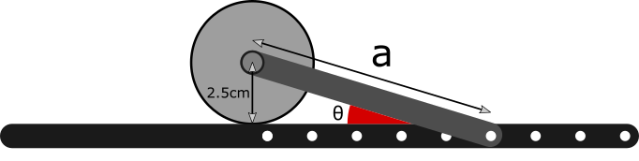I noticed when trying different secondary arm lengths that the longer the secondary arm was the smaller the angle between the secondary arm and the main arm. This is because the counterweight is touching the main arm and stops it as shown.

Now I thought this seemed like a bit of a source of an inaccuracy and so I decided on an angle (45°) that I would try and keep constant for all settings.

To hold all the secondary arms at the same angle made a few new parts.

## Modular ramps 1.0

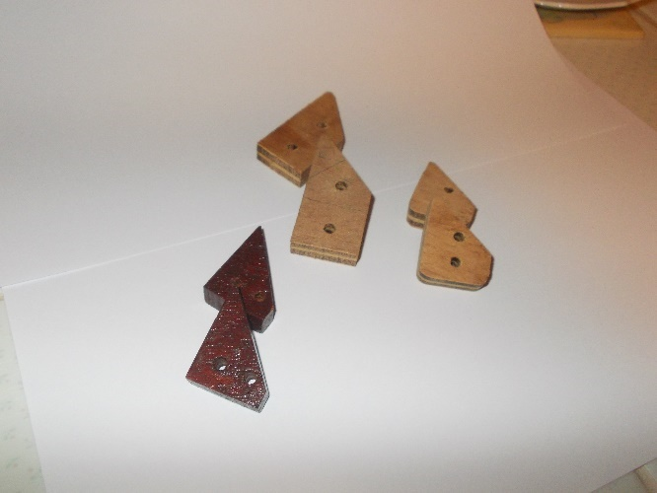These took a few attempts before I got the orientation right and them to fit and be in contact along the whole ramps surface. The ramp was made to be exactly 45°.

The idea with these parts was that they could be attached to two of the holes in the main arm at a set distance from the hole currently housing the secondary axle. This meant that except from the holes closest to the main axle these could hold the secondary arms at 45° at every hole in the main arm.

## Bearing housings 3.0 (ramped)

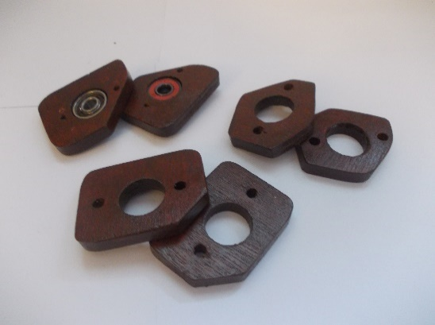The modular ramps needed three holes spare to fit so for the smallest main arm settings I needed to make three different bearing housings which would hold the secondary arms at the correct angle. I managed to turn the bearing housings 2.0 into the right shape to hold the secondary arms attached at the second closest at the right angle which saved a bit of time but then had to make another slightly larger one for the third closest hole.

For the closest hole, which was 3cm from the main axle, I had to use 4mm holes instead of the 6mm holes I was using before so I could fit the ramp close enough to the main axle. Unfortunately, this meant I also had to make another main arm with smaller bearing housing holes just for this specific setting which right of the limits of how close I could go to the main axle.

## Main arm 2.1

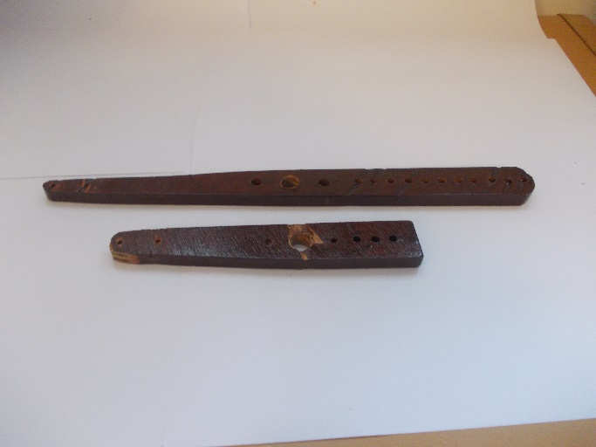I traced the main arm 2.0 and simply made it with less secondary axle holes and 4mm bearing housing holes.

## The release system 1.0

This idea came straight from my inspiration for this project, Tom Stanton’s whipper trebuchet. It was basically some string tied to the bottom of the frame to and then looped onto the secondary axle bolt. Then another piece of string attached to the top of the loop which would be used to pull the loop off the secondary axle bolt and fire the trebuchet.

There were two large issues with this system, however, the first being that every single setting of the trebuchet would have a different distance from the hole where I tied the string to the location of the secondary axle bolt at the point where the trebuchet was just below the balancing point.

## The release system 1.1

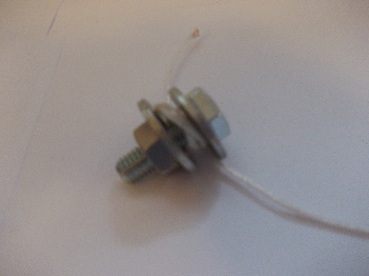This attempted to solve the first issue by providing a way of regulating the length of the string easily without having to re-tie it all. To decrease the length of the string I could simply loosen the nut then wrap the string once more around the short bolt, then re-tighten it to secure the string.

When testing this solution though it produced the issue that the weight of the bolt itself would change the balancing point which would be a source of inaccuracy and so I had to scrap this idea.

## The release system 1.2

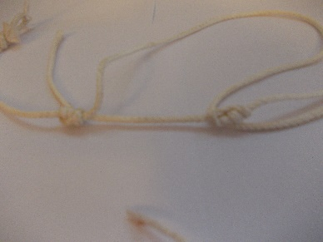This time I got the idea to tie an adjustable one-way knot using the help of the internet. It around four or five attempts before I had successfully tied the special knot(s).

It worked much better than the previous solution as it was a lot lighter. The was one issue with the system in that when setting up the trebuchet to fire it was quite tricky to put the marble into the carriage without accidentally tipping the trebuchet the opposite way and it to misfire it.

## The solid sling problem

Every traditional trebuchet I have seen so far has the counterweight on the bottom of the frame, which is flat, behind the firing pin so when it is fired the projectile is dragged along the bottom of the frame before changing direction and being flung the other way.

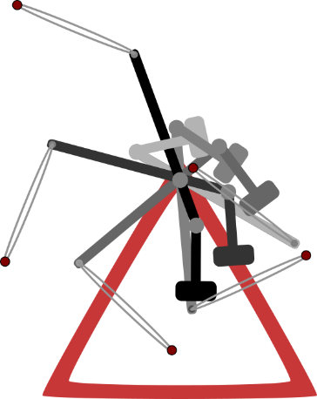This is however not the case with whipper trebuchets for the simple reason that a whipper trebuchet main arm is rotated a lot further before it reaches its starting position. This is why for every other whipper trebuchet I have seen the projectile is put in between the secondary arm and the main arm so it is always behind the firing pin and hence the loop wouldn’t come off the firing pin.

## The carriage holder 1.0

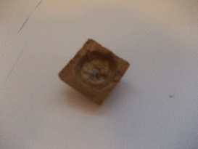The marble and carriage were quite hard to balance on the main arm so I made a new part for the trebuchet to help hold the carriage there; a tiny bowl.

## The solid sling problem continued

After a few tests, all of which were misfires, there was obviously something going wrong. Upon investigation, with the help of a 240-fps camera, I discovered that when I fired the trebuchet, the carriage came out of the holder and when it fell the loop in the fishing line came off the firing pin when the firing pin was at the bottom of its circular path instead of near the top. There are two reasons for this; the first is when is free fall the weight of the sling itself caused the sling loop to accelerate downwards fast than the firing pin was accelerating and so came off. I find this quite hard to believe however as the fishing line is extremely light and so the air resistance would be too high compared to its weight to move faster the firing pin but it’s not impossible.

The second reason which I believe is more likely responsible for this effect is that the weight of the marble and carriage cause it to move faster than the firing pin at that time and the properties of the fishing line being quite resistive to bending proportional to the mass of the loop. This essentially causes the fishing line to act more like a rod than a piece of string and so pushing the loop of the firing pin instead of it falling off under its own weight.

I then got the idea that if the projectile did not fall before the sling was under tension then the loop would never come off the firing pin. To do this the carriage would have to be horizontal with the firing pin at the time of firing instead of above it. To achieve this, I created the carriage holder 2.0

## The carriage holder 2.0

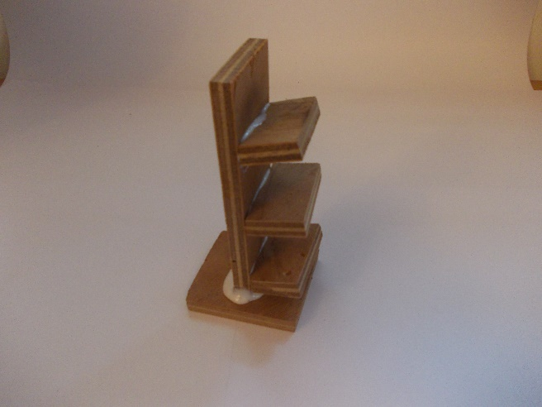I added three different platforms for the different settings that have a higher position of the firing pin at the balancing point and so would need a higher place to put the carriage. This would affect the GPE of the projectile but that was quite insignificant compared to the GPE of the counterweight so I thought it was a necessary evil.

## Firing pin cap 1.0

When testing this I found that it was very finicky to arm the trebuchet as although the carriage was 90° behind the firing pin if the sling wasn’t in tension then it would come straight off and was quite tricky to put back on so I tried making a cap to hold it on until I was ready to fire.

## The frame interference problem

This problem was heavily intertwined with the previous as every attempt to fire my trebuchet failed for one or more of these three reasons: the carriage hit the frame, the loop in the fishing line came off prematurely or the marble didn’t come out of the carriage even after the loop came off the firing pin. These correspond respectively to the problems I have called the solid sling problem, the frame interference problem and the sticky carriage problem.

The frame interference problem happened as the carriage with the marble would hit one of the two support struts in my frame which left me with a few options.

Now I had thought that the carriage holder 2.0 would help as the carriage would no longer be falling down when the trebuchet was released as instead it would only fall a tad before being lifted across and up by the firing pin assembly. This ended up not working as at the balancing point the trebuchet would accelerate at an increasing rate as the force would increase as the counterweight moved further from the main fulcrum.

Instead I was left with two options; make a larger frame or make the main arm and sling smaller. I didn’t really want to make my main arm smaller as that would make the trebuchet less powerful which I was very reluctant to. The frame 1.0 was also the first thing I made and was very rough, untidy and lopsided so I was quite happy to renovate the largest yet worst part of the whole trebuchet.

## The frame 2.0

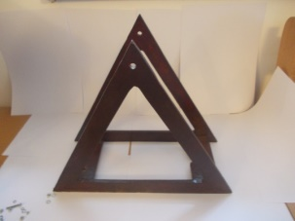This frame was nearly identical to the first with the only differences being that is was a lot larger (27cm tall) and wider connecting struts. It was also made with much more precision and sanded down to make it smoother as well.

Because I was now using the main axle 4.0, I no longer needed the notches to the holes so I simply didn’t add them.

## The frame interference problem continued

Following the creation of the frame 2.0 came more testing. While testing I found that the carriage was still just glancing the frame connector which destabilised it and caused a misfire so I cut off the bit of the connector that the carriage was touching.

This, other than the occasional occurrence, fixed the frame interference problem

## The sticky carriage problem;

Another source of misfire happened to be the projectile, a marble, not coming out of the carriage right after the loop had come off the firing pin which would often result in the projectile being thrown straight down or even just staying in the carriage after being fired.

To fix this problem I messed around with the depth of the carriage compared to where the fishing line was tied to it. If I made it too shallow then the marble wouldn’t stay in the carriage long enough and would come out prematurely whereas if I made it too deep it wouldn’t come out at all.

After a lot of tweaking and testing I couldn’t find a good depth so I instead thought of a different design. I made the carriage asymmetrical so on one side, the side the loop was attached to, I made it evenly sloped whereas on the other side, the side with the fixed end, is was curved much to the shape of the marble. This was so that when both the loop end and the fixed end were under tension the marble wouldn’t be able to come out but when the looped end came off the firing pin the carriage would rotate and the marble would be free to go up the evenly sloped ramp and out to freedom.

This had excellent results and is one of my best ideas yet and makes me glad I used copper wire which is just the right mix of malleability and rigidity that allows me to tweak and change it to my heart’s content.

## The solid sling problem continued again

Through more testing and slo-mo footage I found that the carriage holder 2.0 was an inadequate solution as even with the firing pin cap it was just too hard to setup the trebuchet for a fire which would cause big issues later when I had to collect data, especially when there are 144 different settings that I have to collect data for, ignoring repeat readings.

Even if setup perfectly the sling still sometimes came off the firing pin just after I fired it due to the carriage falling faster than the firing pin moved immediately after being released.

While brainstorming for a better way to hold the carriage I thought back to the first time I ever fired and earlier version of my trebuchet. It was with all the first edition parts and I noticed the carriage hitting the frame so I put a bit of card leading up to the first connecting strut that it would hit so it would instead go up the gentle ramp. To fire it merely held the whole mechanism back with the carriage and sling itself. This actually worked surprisingly well and was the first and only time I had ever been able to fire the marble in the right direction.

So, I tried to remake the conditions that led to such success.

## The carriage slope 2.0 kinda

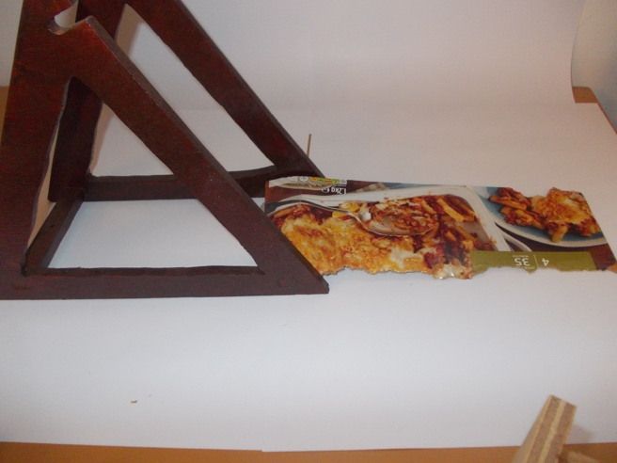I made it from the box my last dinner came from and fixed it to the frame connector strut with some scotch tape.

## The solid sling problem continued once more

It felt unnatural, but instead of firing the trebuchet by pulling the string loop off the secondary axle, firing the trebuchet by releasing the carriage from my hand with the tension in the sling holding the whole force of the mechanism meant two very important advantages.

For one, the trebuchet was a lot faster to fire which was crucial for its purpose of data logging different arm ratios. This was because I no longer had to bother with adjusting the release string to the correct length or fiddle with trying to get the sling under tension with the loop on the firing pin and the carriage resting on the right level of the carriage holder 2.0. Instead I simply put the marble into the carriage put the loop on the firing pin and drew the trebuchet back with the carriage and sling until I felt it was just before the balancing point before releasing it.

For two it meant that however I fired it the sling would always be under tension which meant no more to the premature slipping off of the fishing line loop from the firing pin and possibly the end of the solid sling problem once and for all.

This however wasn’t a perfect solution as it meant a lot of variation in position of the carriage at the moment of firing as I can only guess where I released it last time. So, to fix this issue I made some more parts.

## The carriage release system 2.0

One of my most brilliant ideas to date was to use a crocodile clip to replace my hand as the release system. So, my task was to make a system that allowed me to easily adjust the release position between different settings but also so keep things like height of carriage at release as similar as possible to decrease inaccuracy.

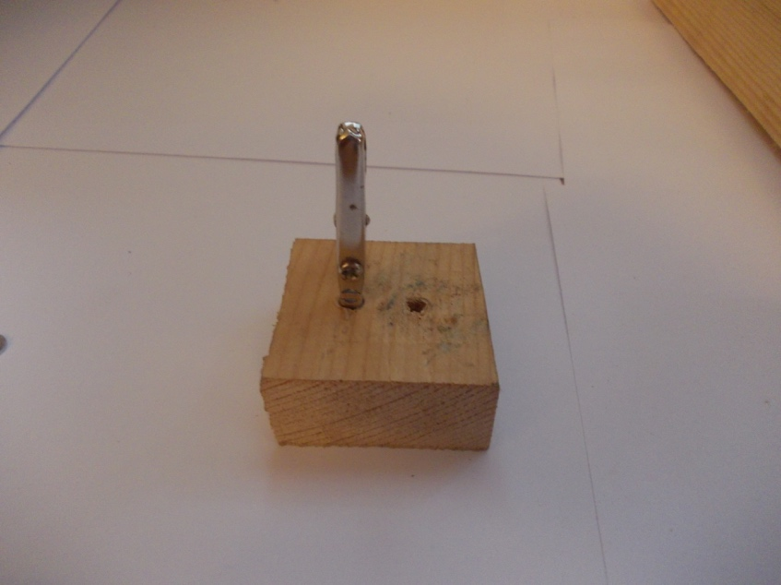I came up with this from a bit of pine wood. It has a slot cut down the centre to act as a rail, the large piece was then connected to a different piece with two wood screws. The smaller piece had a 11mm hole through it which would then be used to bolt it down to a separate rail I would make next for the horizontal movement.

I also made another block from the same wood in which I glued in a crocodile clip and could bolt that to the biggest piece which would then let me set the vertical height of the crocodile clip. The one drawback to this design was that unless the two bolts were really tightened the crocodile clip block liked to rotate around its bolt quite a lot.

## The plank 1.0

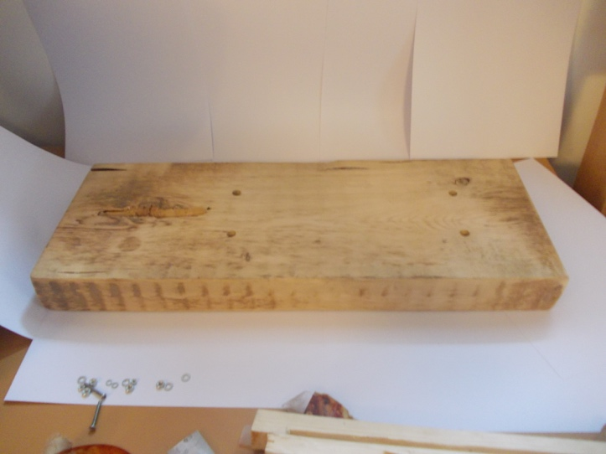I needed to be able to hold my trebuchet down so it wouldn’t dampen the effects of the main mechanism when I fired it. Most people with large trebuchets use sand bags or similar but as mine is so small I decided to simply bolt it down to a big heavy plank of hard wood that I could then later weigh or clamp down if need be.

This plank also had the horizontal rail for the carriage release system 2.0.

## The connecter strut spacers 2.0

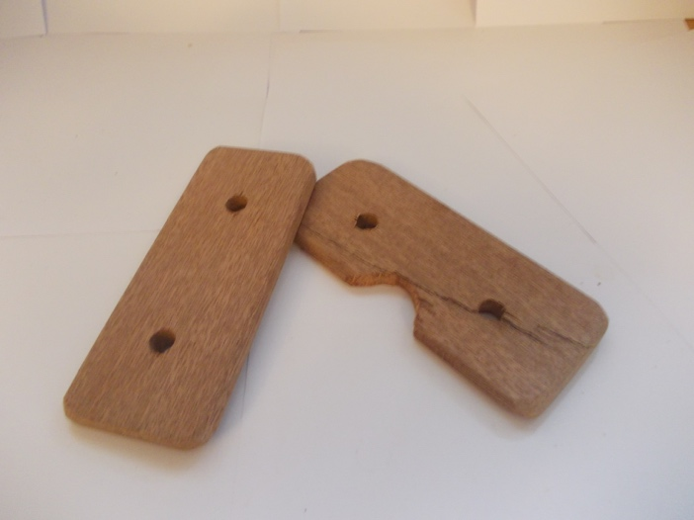I had decided to use four 10mm bolts to hold down my trebuchet from the strut connectors, however, these were not flush with the bottom of the frame so I made so spacers that were exactly the right size to fit under the strut connectors and make sure they were nice and solid. I even cut the same notch out of one so it matched its strut.

## The main arm 2.2

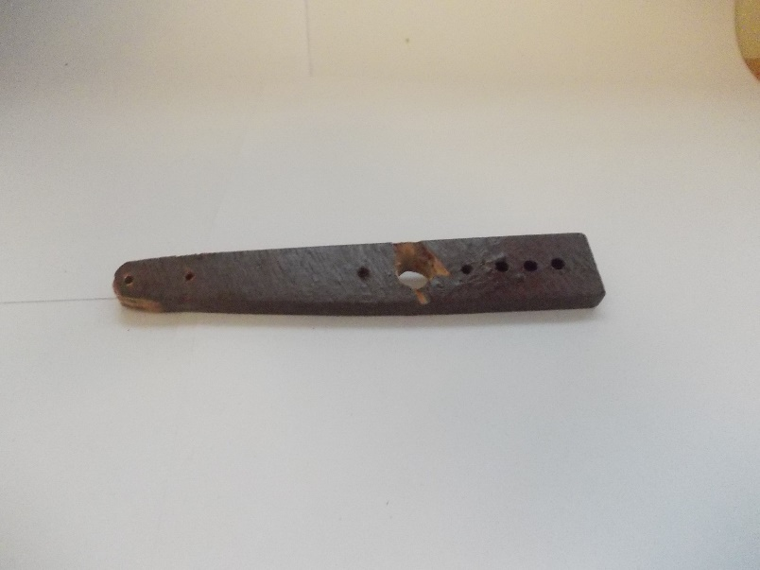I was doing some more testing at this point, revelling in the slickness and gun-like trigger release mechanism of the crocodile clip when I found the starting position of the carriage affected the swing pattern directly after release which meant that the carriage was sometimes hitting the frame connector again. So I simply thought, screw it ill just chop the end of the main arm so the combined total of the main arm and sling will be just less than the distance from the main axle to the frame connector so it will be impossible to ever hit the frame again because I have had enough of that for one lifetime.

## The main arm 2.3

I did the same to the longer main arm as the shorter making to cut the firing pin side to exactly the same length.

## The carriage release system 3.0

When doing some more testing with longer secondary arms I found that the main axle rotated so to get to its balance point that it was horizontal. Now this wouldn’t be an issue for those people who keep their carriage resting between the main arm and the secondary arm however for poor old crocodile clip releasing me, I needed to keep the carriage 90° behind the firing pin which meant releasing it quite high up which was an issue for two reasons; the first is that is it meant a bit of inaccuracy caused by the change in GPE but as I’ve said before I can live with that. The second reason why it’s an issue is because my carriage release system 3.0 wasn’t tall enough to hold the carriage at the right height.

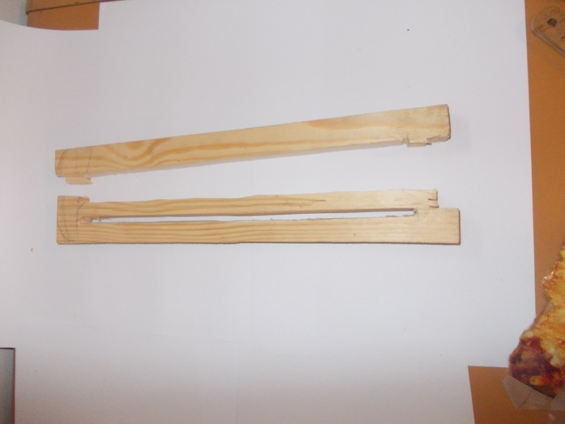So, I tried making a new one but this time with two rails so the crocodile clip holding block wouldn’t be able to rotate. I cut both slits out with a fret saw but unfortunately, one of the slits was slightly too small on one half to let the bolt along it so I sanded it wider until the bolt fit.

I then began on making a joint to the bottom piece but I went a bit crazy with the chisel and managed to split the whole thing in two down the soft wooded grain which was weakened terribly by the long slits I’d made. This made me very sad as I had spent a few hours on this piece of wood and it had turned around and spat in my face (figuratively speaking of course as wood does not tend to have the intelligence associated with facial recognition, yet…).

## The carriage release system 4.0

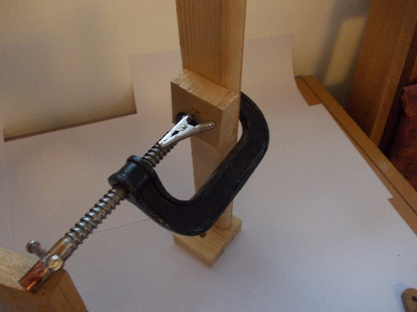Quite put out with how the previous version went, I scrapped the whole vertical double slit idea for one a lot easier to manufacture; a g-clamp.

It was a tad more effort to change the height but for the moment it was fine. The vertical piece was secured to the bottom piece by screws and glue this time.

## The fragile release angle problem

During the setup for the repeatability experiment I needed to get my trebuchet to fire at the right general angle. The things that I effected the release angle that I have found out from both traditional trebuchets and my own experimental work are as follows:

* Firing pin angle
* Sling length
* Carriage release position
* How close the trebuchet is to its balancing point when released
* Main arm length
* The orientation of the loop on the firing pin

The first thing that surprised me about these factors is the sheer volatility of some of them. For example, mere 2mm change in the firing pin angle (roughly 4°) could cause the trebuchet from firing horizontal to firing at 45°.

The second thing that surprised me is that the last fact, the orientation of the loop on the firing pin, would even change the release angle although admittedly it was only from a few shots with and without that I reached this conclusion. I added it to the control variables out of the sheer thoroughness of it and the humour it gave me.

When doing some testing much earlier with the release system 2.0 with longer secondary arms, I found that the balancing point of the trebuchet was so much further rotated than I had seen before. This then meant I had to move the release position of the carriage so that it was 90° behind the firing pin so the loop would stay on before firing. Although I hadn’t thought of this as too much of an issue in terms of energy stored it did become an issue when I was doing my repeatability test that a small change in the release height could also affect the release angle of the projectile.

For my main experiment, I was going to have to go all the way from long main arm to short secondary arms settings all the way to short main arm to long secondary arm settings and everything in between trying as best I can to keep everything else that I could as constant as I could reasonably make them. But, if for some settings I had to change the release position of the carriage to allow the trebuchet to be fired at all then that could then affect the release angle of the projectile which could affect the release velocity which could mean my whole experiments validity goes POOF, out the window, down the drain, down the pub and more of the same.

I left this problem to mature and distil in my brain for a few days.

## The background 1.0

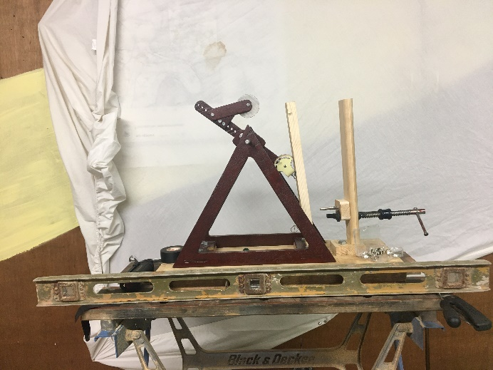I needed better contrast and a constant background for the auto tracker function in tracker and what else is better for such a process than a bedsheet.

To attach to stetch the bedsheet against the doors I used lots of thumb tacks and a hammer.

## The fragile release angle problem continued

It was at this point that I had worked out an equation for the angle of the main arm at its balancing point and the set of all possible settings for my trebuchet shown below:

$$θ=180-\sin^{-1}{(\frac{\frac{a\sqrt{2}}{2}}{\sqrt{a^{2}+b^{2}-ab\sqrt{2}}})}$$

$$C=\left\{\left(b, a\right) \right| b∈N, a∈N,a≥7, b≥3,a+b≤0.2395\}$$

Or: $C=\{\left(3, 7\right),\left(3, 8\right),\left(3, 9\right)…\left(15, 6\right),\left(15, 7\right),\left(16, 7\right)\}$

With these equations I could now calculate the range of possible angles of θ. Or what would be even better than that would be to graph the equation for θ between its limitations. The problem with doing that is that there are three variables and so graphing it is quite tricky as paper is quite annoyingly two dimensional. There are methods of graphing three variables two dimensionally but none that I could find that were easy to use so I made a gif of 14 graphs of θ in terms of *a* with b as a constant that stepped up by 1 from 3 to 16 for each graph. I can’t show the graph here unfortunately but if you would like to see it you can do so here:

<https://giphy.com/gifs/mFHVnwVVtvZC4p8LYU>

After looking at the strange sharp corner on the graph and struggling with working out an interior angle of a obtuse non-right-angle triangle using the sine rule it became obvious to me that the arcsine function used by all calculators and computers will always output the acute value for the angle which means that it will always be $≤$ 90°. And as my equation for θ takes the result of the arcsine function away from 180, θ will always be greater than 90° and hence the graph changes direction sharply when at θ = 90°.

The maximum that θ reaches is when *a* is minimised and *b* is maximised, which makes a lot of sense when you imagine the corresponding trebuchet setup. The minimum that θ reaches occurs when *b* is minimised and *a* is maximised. I have also manually corrected the issue with the sine function for the minimum value of θ by not taking it away from 180.

**Minimum (3, 20) : $θ=\sin^{-1}\left(\frac{\frac{20\sqrt{2}}{2}}{\sqrt{{20}^{2}+3^{2}-\left(20\right)\left(3\right)\sqrt{2}}}\right)=51.7°$**

**Maximum (16, 7) : $θ=180-\sin^{-1}\left(\frac{\frac{7\sqrt{2}}{2}}{\sqrt{7^{2}+16-\left(7\right)\left(16\right)\sqrt{2}}}\right)=155.9°$**

The idea I got from this calculation was to find a position for the carriage release system that would work correctly for the minimum θ and then just the adjust the horizontal position of the carriage release position so that the GPE of the projectile did not change when changing the setup of the trebuchet and therefore the balancing point.

## The build up to the main experiment

It was at this point that I had finished the firing pin angle experiment and its results that showed that the release angle of the projectile has very little impact on the actual exit velocity of the projectile. This then gave the green light for the main experiment and meant the fragile release problem was not quite solved but definitely proved inconsequential if certain requirements are met, namely that the loop does not slip off the firing pin prematurely which would correspond to a misfire.

With the main experiment on the horizon it now became a matter of fixing a few small issues ready for the main experiment.

## Secondary arms 2.1

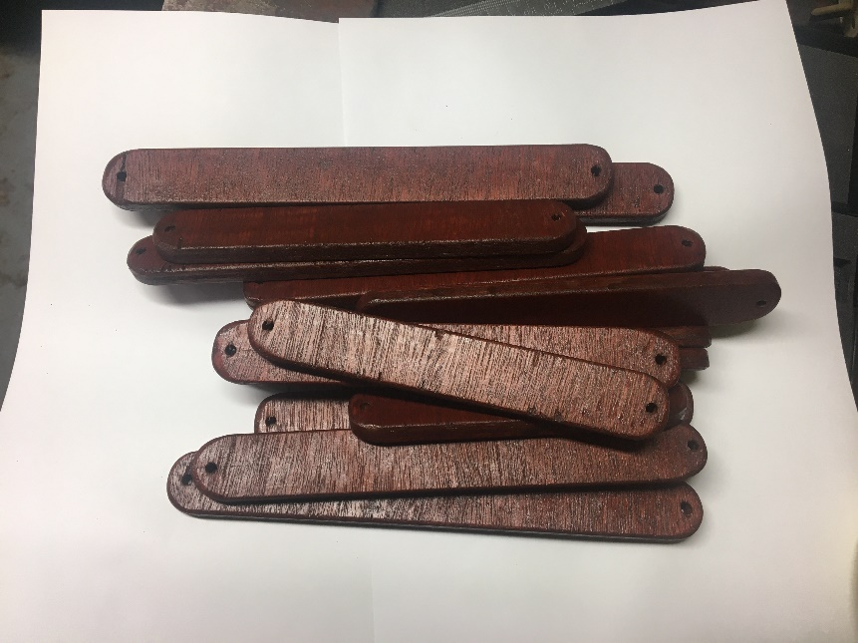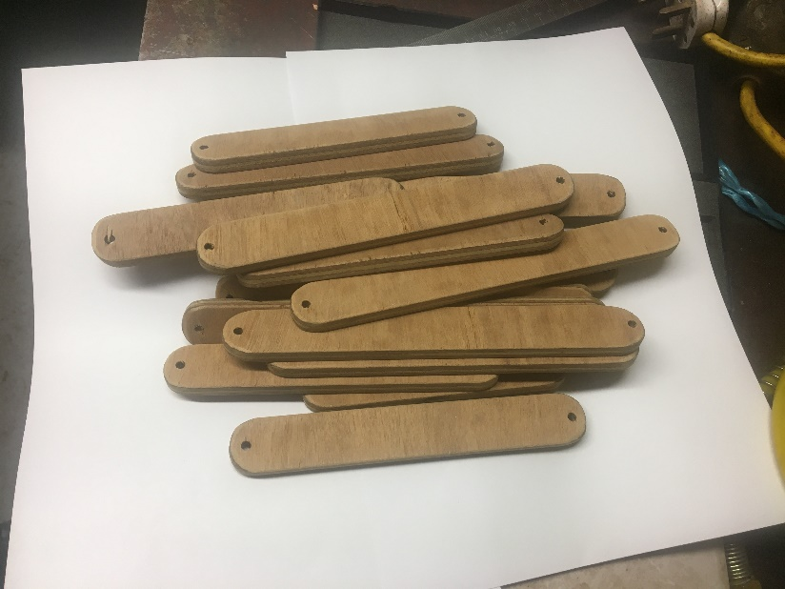The first issue was the fact that my improved frame height which I used to calculate all possible trebuchet combinations actually showed me that I needed more longer sized secondary arms. I also needed another 12cm one as I lost one of the pair. The largest size that my frame and counterweight would allow is a 20cm set of secondary arms and at the moment I only had from 2cm up to 13cm so I made another batch from 14cm to 20cm exactly the same way I made the first batch.

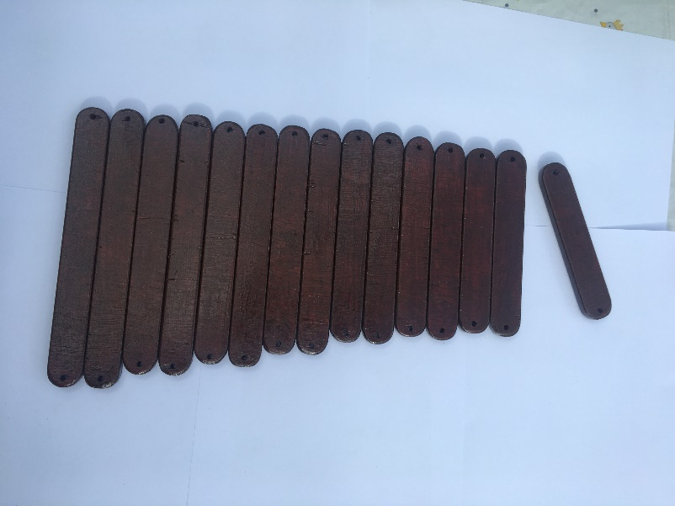It was a whole day’s work to make these even with the practise I had from making the smaller versions. This was mainly due to the precision required for marking out the holes and the sanding process which all had to be done by hand for a smooth enough finish.

## Trebuchet setup display system 1.0

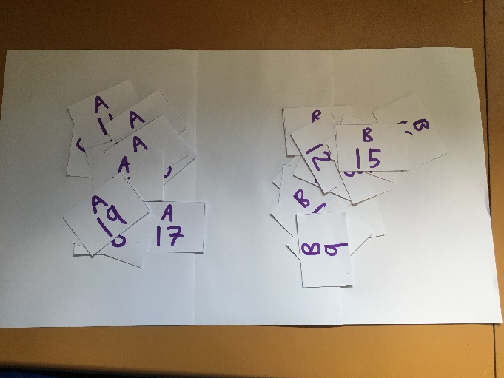When doing the main experiment, I found the need to know which setup is currently is on the trebuchet for each shot so went a bit arts and crafty and made some paper slips that I could use to display the current trebuchet setup.

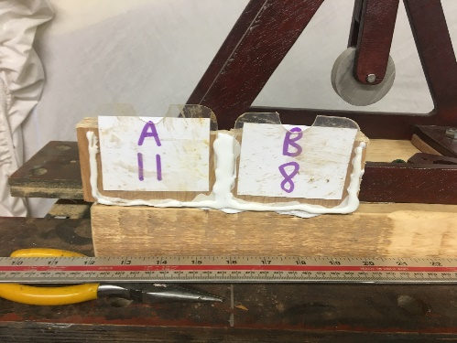I then needed something to hold two of these, one for the current secondary arms (A) and one for the main arm (B), in the frame so they would be clearly visible and not blow away. For this I took some clear plastic from my recycling bin and cut it to size and added nice semi-circular notches for ease of access to the sheets to be able to change them easily. I stuck these to piece of wood on three sides with some hot glue to make two little pockets for two paper slips to fit into. I stuck this with some more hot glue to the plank so it would always be visible in the recording but not get in the way.

## Secondary arms 1.3

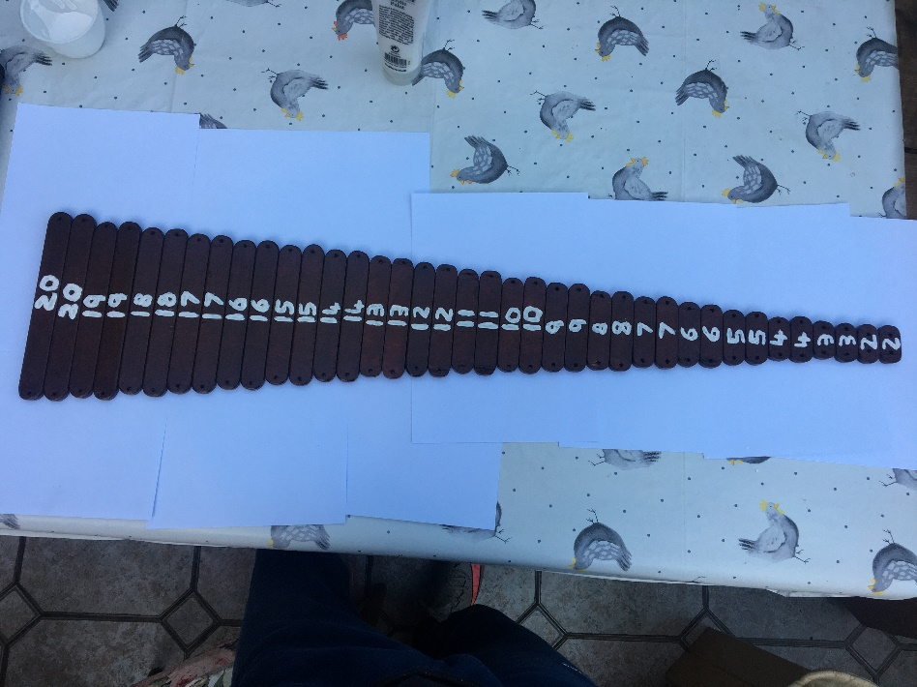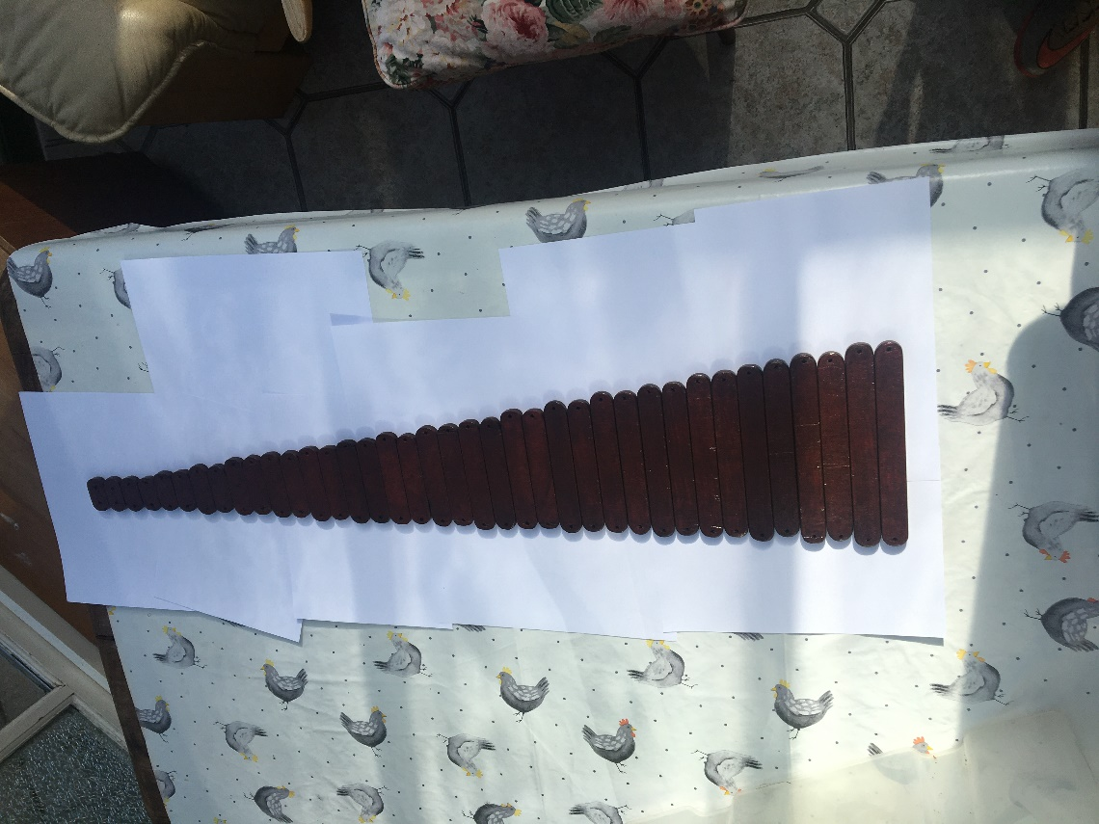This was another subtle change to increase efficiency in the main experiment. Before this upgrade, to find a specific set of secondary arms was relatively easy if they were sorted by length and I had a ruler in hand but if they were not sorted then even finding any pair became difficult became a challenge let alone a specific pair.

Sorting them isn’t that hard but I wanted to go one up and so I decided to paint the length of each secondary arm on it in white as not only did it remove the need for a ruler when finding secondary arms but also made them look pretty cool despite terrible skills with a paintbrush.

## Bearings 3.0

## The main arm 2.4

I noticed one day that the secondary arms could wiggle side to side much too much in the secondary pivot holes in the main arm 2.3 compared to the main arm 2.2 and so I investigated a bit and found that the secondary pivot holes in the main arm 2.3 were 5mm whereas the main holes in the main arm 2.2 were 4.5mm. Seeing as the secondary was a 4mm bolt it made a lot more sense for the pivot hole to be 4.5mm which still allowed free rotation but not as much wiggle from side to side. Other than this the main reason for a new main arm was that the current one was a few settings short of all the necessary setting. The blank main arm was quite easy to make as I could use the current main arm as a stencil to mark out the next one and simply extend one end to add more secondary pivot holes..

## The main arm 2.5

I wanted to test the bearing housings for the smallest main arm settings as I remembered in the past that they sometimes didn’t sit flat and I wanted to further investigate. So, I went and got the main arm 2.2 which is specifically made only for this setting as it needs smaller bearing housing holes. I saw that on my main arm there were multiple secondary pivot holes and somehow, I got the stupidly redundant idea that I didn’t need all the extra holes any more as the other main arm is planned to be used for every other main arm setting. It was when I tried putting the bearing housings onto the main arm that I realised my silly mistake. I assumed that the smallest secondary pivot hole was the one that I needed to keep and the others needed to go. I assumed wrong. It turned out the hole before the last actual pivot hole was the actual smallest main arm setting. If I had just measured before chopping I could have completely avoided this mistake but unfortunately, I did not.

Now, I had to make an entire new main arm just for one darn main arm setting. I considered simply gluing the piece I cut off back on but I then couldn’t trust it structurally and it wouldn’t look as cool.

The one upside was that the rest of the main arm 2.2 was fine and so I could just trace it to cut out that portion exactly the same.

I ended up just drilling the precise holes first and then leaving the rest of the blank unshaped and unvarnished so I could get back the testing I was doing. I ironically found nothing wrong with the smallest setting bearing housings and they sat perfectly flat with all the secondary arms I found.

## The crazy release rotation problem

This issue caused me some of the heaviest emotions so far in the project such as brutal frustration, sadness, and then finally acceptance in that order. Before proceeding to start the main experiment, I knew I had a few tests to do to make sure nothing would go wrong during the experiment. The first thing I wanted to do with the new, longer secondary arms was to test the longest secondary arms with the smallest main arm setting which would give me the most rotation to the balancing point.

What I found was that the excessive rotation at the balancing point made it the carriage release system non-functional. For the loop to keep tension on the firing pin it had to be what I guessed at least 90° behind the firing pin, when the main arm rotates as far as 51.7° from the vertical then is means that depending on the angle setting of the firing pin it will usually be slightly more rotated from the vertical at the balancing point. If we assumed that the firing pin was set at 28.3° for the default position then the angle of the firing pin at the balancing point for the most rotated setup, maximum secondary length and minimum main arm length, will be 90° from the vertical, which is just meant as a rough estimate. This meant that for tension the carriage and by extension the carriage release system had to be vertically above the firing pin which was an issue.

In fact, it was nearly sacrifice acquiringly bad. Firstly, there is the issue of holding the marble and the carriage before release. Currently I had used a crocodile clip to hold the carriage and the marble would stay in the carriage from our good friend gravity. When the carriage is upside down gravity is no longer so friendly and the marble will fall out. To solve this, I came up with the idea to file the jaws of the crocodile down so instead of tiny teeth which held on the wire of the carriage they would hold directly onto the marble and solve the issue. This was unfortunately unviable as my one and only crocodile clip would not bear its jaws wide enough to hold the marble. Even if I had gotten such a solution to work I found that it would have been irrelevant as when the carriage and marble were dropped vertically with the trebuchet starting at just before its balancing point the marble, having a much smaller cross-sectional area to mass ratio, overtook the carriage in the acceleration downwards and fell harmlessly into the base of the trebuchet instead launching valiantly into the eyes of my enemies.

I briefly held conscious thought to a brush like thing holding the marble in the carriage unless it had enough kinetic energy to escape which could only happen at the release moment but it was quickly overtaken by the problem of the counter weight now hitting the carriage release system arm. It was at all this problems and issues that made me very frustrated and sad. All I wanted was to collect as much un-biased data from the largest variety I could and the big bad gravity went and ruined it with its stupid laws.

After much head banging and head scratching, I came to a conclusion. The further rotation setups of the trebuchet were going to need a whole different carriage release system. But the current carriage release system was the only system I found that worked for lower rotation setups. This then lead me to the conclusion that I would need multiple release systems for the different amounts of rotation of the trebuchet and their respective issues.

With this mental proclamation I felt great acceptance that soothed the harsh wounds caused by that evil thing called gravity.

This of course left me with more choices and decisions to make. Should I just carry out the main experiment now with the setups I can do? Should I wait until I also have another carriage release system that works for higher rotation setups, so I can do every setup in the same experiment? Am I ever going to do the experiment? How long is a piece of string?

This is not to mention I still didn’t have the means to separate the setups from too high rotation and not. This is also not to mention that I also have not thought of how I would actually pull off the different release system but it shouldn’t be too hard as although gravity becomes an enemy, I believe that the setups become more powerful. I think this because on the one of the many tries, I did at firing the maximum secondary arm minimum main arm setup I managed to fluke a shot in where the marble stayed in the carriage and the marble flew so fast it chipped against the back of the workshop wall. I was glad I had my safety goggled on.

Leaving the other questions to mature as I thought about them more, I decided to solve the relatively simply issue of separating the different setups from their necessary release systems which I will document on the main document.

# The brutal counterweight problem

When using a high main arm and medium secondary arm setting, I had the issue that the counterweight kept hitting the carriage release system when it was falling after release. I don’t think I have encountered this issue before now because since I have recently shortened the sling which has meant that I have to move the carriage release system closer the trebuchet for each trebuchet setup.

I don’t believe that there is any easy way to mathematically calculate how far the counterweight will still hit the carriage release system as you could just take the total of the main arm, secondary arms and the radius of the counterweight but that value would often not be correct as the secondary arms are free to pivot at the secondary fulcrum. It also depends on the position of the carriage release system which also changes depending on the trebuchet setup.

I can think of one easy solution that is to simply slightly move the trebuchet arms assembly across on the main axle so they are no longer in the same plane as the carriage release system so that they can no longer collide. I don’t like this solution very much as is there is the possibility for it to produce bias.

After much pondering I came up with another solution which I like a lot more but it will require a bit more work to implement. The solution is to attach yet another piece of fishing line to the carriage and use it as a sort of buffer to the release mechanism so that the release mechanism can be further away from the carriage at the release point.

Other than the need for some new parts the main fear I had for this solution is that the carriage would not be stable enough being held by only a few pieces of fishing line. Although I did concede that I could probably fix that issue by adding another buffer as two lines will hold an object more rotationally stable than one but I didn’t want to overcomplicate things too much so I hoped that one buffer line would work.

With this solution confirmed in my mind the next issue became: how long should the buffer line be? There were probably easier ways to do this but to solve this issue I investigated the path of the counterweight (which is what decides how long the buffer will need to be) thoroughly in my main document which included in short: my mathematical predicted counterweight path, my real time simulated counterweight path and the real life trebuchet counterweight path.

After doing all that I was able to calculate, using both my simulation and my real-life trebuchet the maximum x-distance of the counterweight for every possible whipper trebuchet setup and use that with the calculated horizontal distance of the firing pin from the main fulcrum at the firing point for every setup to work out the needed amount of buffer for every setup.

With that all wrapped up all that is left is to make the solution a reality.

# The sling and carriage 1.1

The first and easiest of all the changes needed to implement the new buffer line is of course to attach the buffer line to the carriage itself. I went with 16cm of buffer line as that is the first natural number after 15.7cm which is the largest buffer line distance that I found from my study in the main document after exploring the path of the counterweight.

On a side note it was when I was tying this buffer to the carriage that I noticed that one of the solders had release a bit of copper wire so I had to re-solder it which then meant I had to re-tie one of the slings for the umpteenth time so far.

Later that day when I was working on some other parts I noticed when I was looking for a tiny M3 bolt that I had just dropped that there on the floor was my sling and carriage. To my shock and utter despair, the carriage seemed to have been stepped on as it was absolutely crushed. Normally this wouldn’t be an issue as I could just bend the malleable copper wire back into shape, however, the solder of one side had broken off completely which means was the real kicker. You see it is not just as simple as resoldering the broken joint as the solder that I had broken was one the side opposite the permanent fishing line sling line which meant that when I was tuning the carriage to fix the sticky carriage problem that was the side that I painstakingly and awkwardly filed down to allow the marble to pass smoothly. Not only that but when soldering the conductivity of copper comes out to play and it often ends up burning or melting off the all fishing line attached and can even melt the solder on the opposite joint enough for the whole thing to come apart if it is not held together carefully with multiple crocodile clips.

So from one aspect, I might have well have just chucked the whole thing in the bin for all it was worth to me now.

# The carriage and sling 2.0

It’s exactly the same as version 1.1 just made from fresh copper wire, solder and tears. Well, there is one very slight difference in that by a better ramp of the bottom copper wire on one side I was able to avoid the sticky carriage problem. The only sacrifice being a few very minor burns in the process.

# The plank 2.0

When I first made the plank 1.0 I did not think I would ever have to make another but here we are I guess.

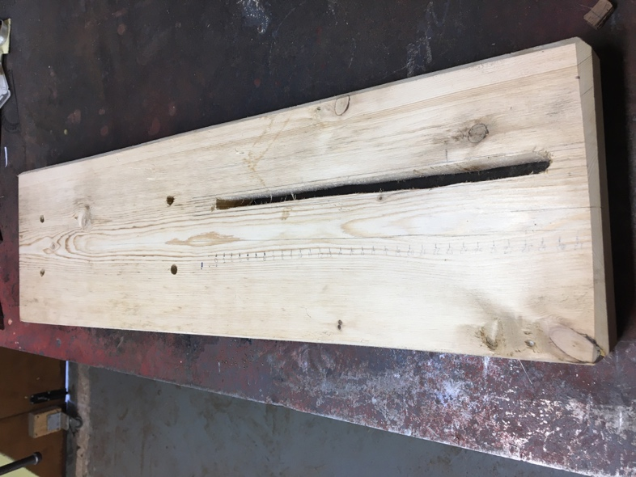The issue with the previous plank was simply that the slot in it was not long enough now that I am using a 16cm buffer line from the carriage to the release system.

There are two slight differences other than the increased length, the first ia that the main slot is purposely designed in accordance with the carriage release system 5.0 so the carriage release system firing pin, or as I like to call it “the second firing pin”, with be in line with the centre line of the trebuchet. The second different is the addition of some measurement markings for the x-axis of the new carriage release system.

I also think the sanding came out much better than last time which makes it look very clean and cool in my opinion.

# The carriage release system 5.0

# My last attempt at this was a bit downhearted after the incident with the carriage release

system 3.0 but I always knew I would have to revisit this part to make it more permanent and repeatable. And that’s even without the fact that I am going to have to redesign the whole mechanism portion.

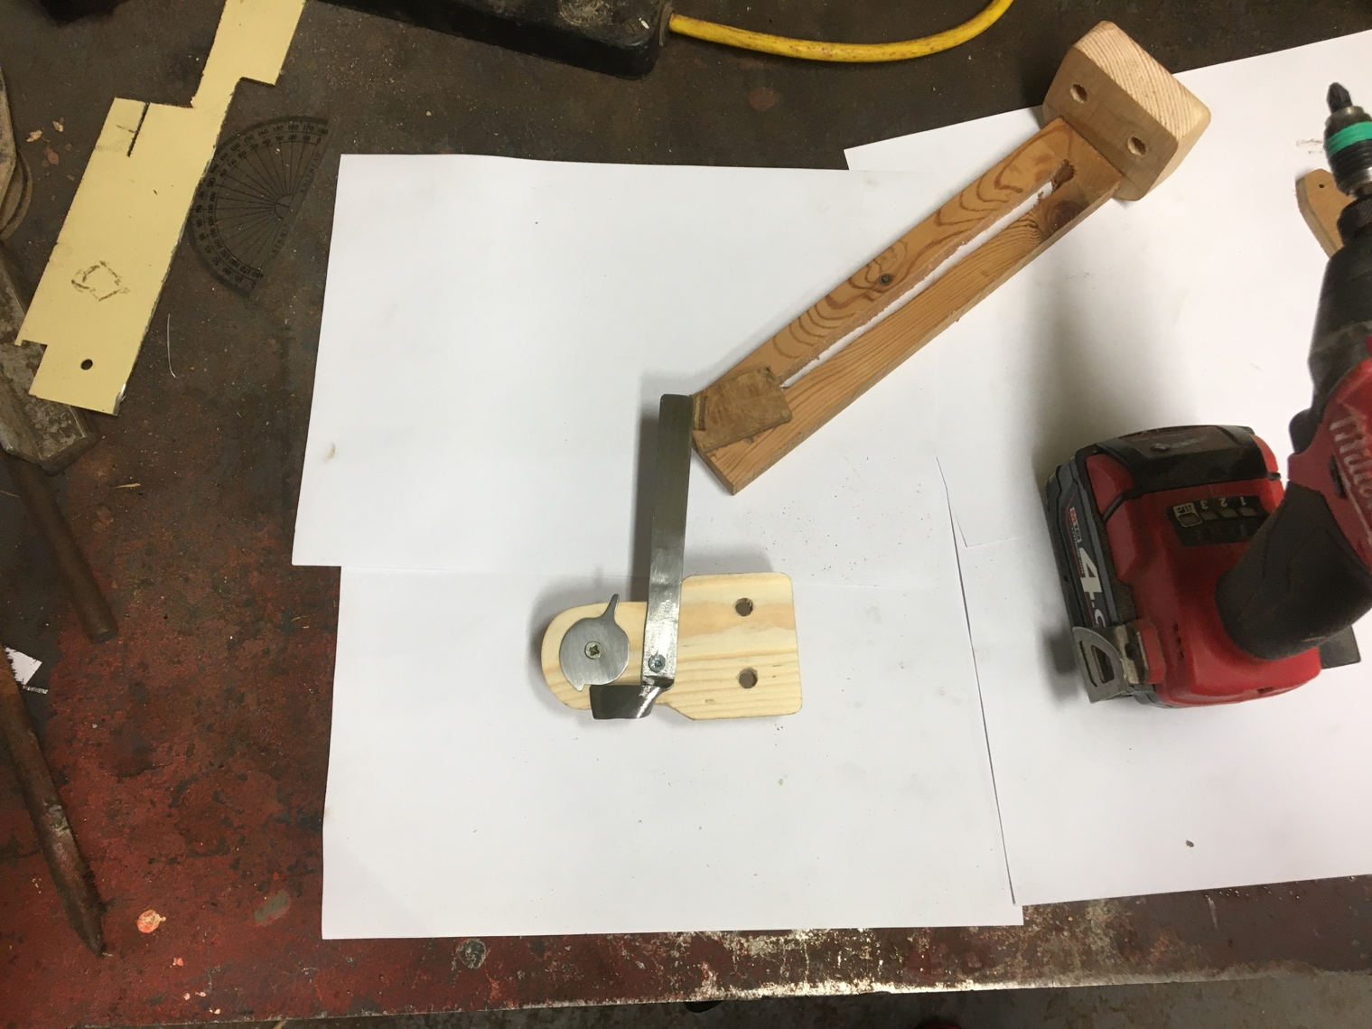Ever since the carriage release system 2.0 I have used a crocodile clip to hold onto the carriage until release however not I am releasing the carriage via a buffer line so I can no longer use a crocodile clip.

The simplest way to release a fishing line is just like my trebuchet, which is with a firing pin. So I need some sort of release mechanism that would keep the firing pin locked until I wanted to fire it at which point I could somehow activate a mechanism to release the firing pin and therefore, trebuchet.

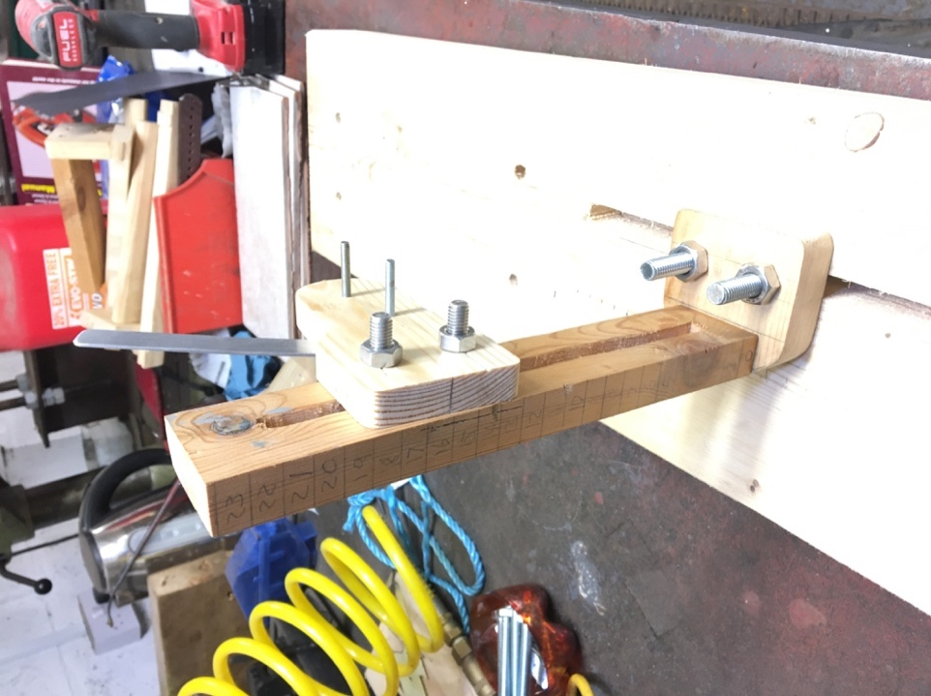I tried googling release mechanisms however most of them were either too complex or simply not suited for my situation so I decided upon my own two-part design. I also decided to make them out of metal as it felt right to make mechanical components out of steel for some reason.

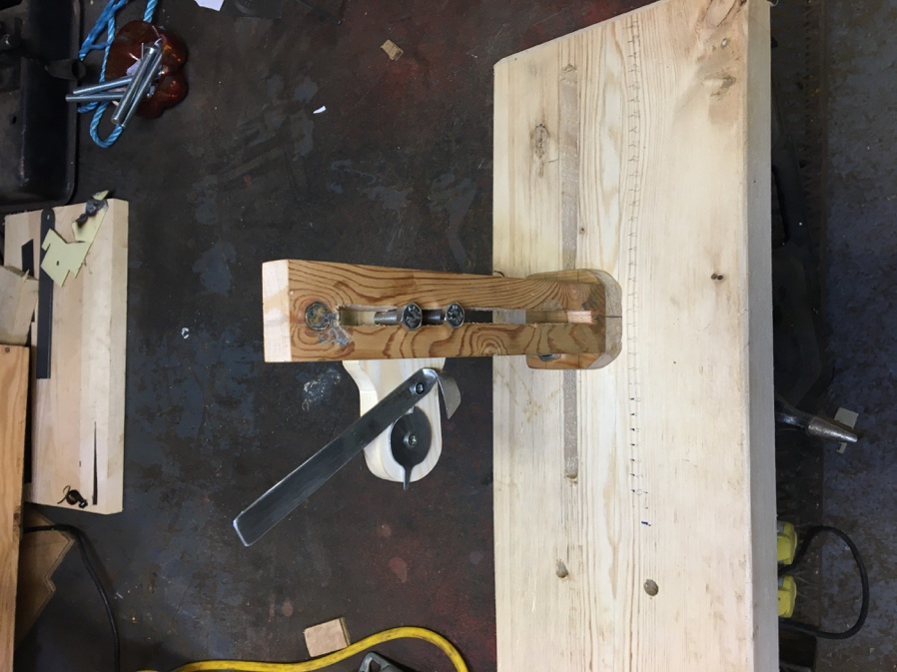I also decided to bury the hatchet and revisit the idea of adding another slot into the vertical part of the carriage release system movement system instead of the g – clamp that I was using up until now as is allow easier, more reliable and more precise vertical adjustment. This time I made two sligh changes to my previous attempt which were one, to use hard – wood instead of the soft pin I used before as it is much much more resistant to splitting. Two, I made one slit instead of the two from before as is much simpler very similarly to the slot made in the carriage release system 2.0, however, to stop rotation of the mechanism attached to the vertical part of the movement system I would simply use two bolts attached to the release mechanism holder instead of the one bolt I used in the carriage release system 2.0.

I made the slit and bolts much larger so they would be easier to adjust by hand.

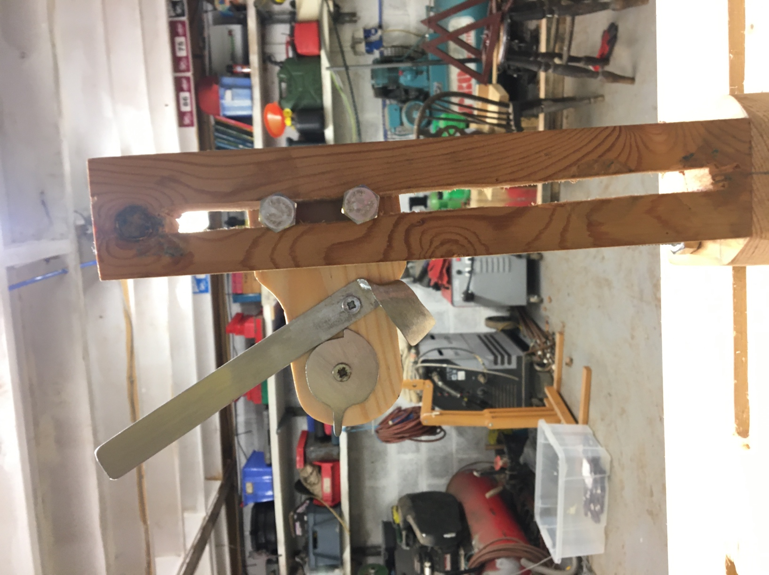The horizontal movement is almost identical the vertical movement system except instead of 6mm bolts I used 10mm ones to match the ones holding the trebuchet to the plank.

I spent a lot of time in the design part of this parts construction and manufacturing because I have made way too many attempts at this part so I wanted something final and solid that would last much longer after my heart was broken by the carriage release system 3.0

One of the most important features of this release system is the addition of built in measurement marking on both the x and y movement axis which allows the ability to precisely record the setup for a specific trebuchet shot in the main experiment for if I need to revisit any anomalous shots after the main experiment.

I also found that by sanding of the paint that comes on the steel the parts went from looking like crude homemade bodges to high-end manufactured parts.

# The firing pin 3.1

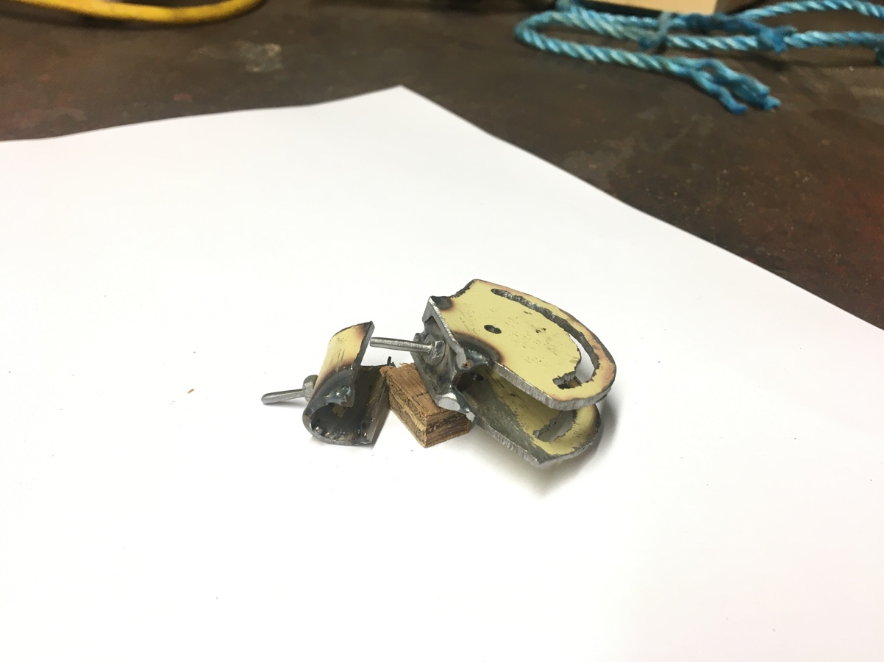The main issue I had with the firing pin is that the distance between the pivot and the firing pin was much larger than it needed to be which could introduce some bias into the main experiment which I must absolutely avoid so then I started think how I could minimise this distance.

On a complete side note it was when I was writing this that I thought of an even better, simpler and cleaner firing pin assembly design but you will likely learn more about that later.

Anyway, the first option would be to simply make another one but the firing pin 3.0 was one of the most time-consuming parts to make due to the curved slots on the two sides for the adjustment bolt to go through. So that brought up the second option which was to modify the existing firing pin assembly.

So, to reduce the distance between the firing pin and the pivot I added a small steel plate further down the firing pin and welded it in place so I could chop all of the excess material off. Unfortunately this did mean I would have to remake a firing pin out of another M3 bolt (Little did I know then that it was all for nothing as I would end up making another firing pin assembly altogether straight after).

# The firing pin 4.0

This part came to me in a lightning like strike of brilliance and inspired a new energy in me with its elegance, cheesy I know…

This part was inspired mostly by the release mechanism I designed for the new carriage release system 5.0 and came to me when thinking of how the improvements made in the firing pin 3.1 could never be perfect as if the 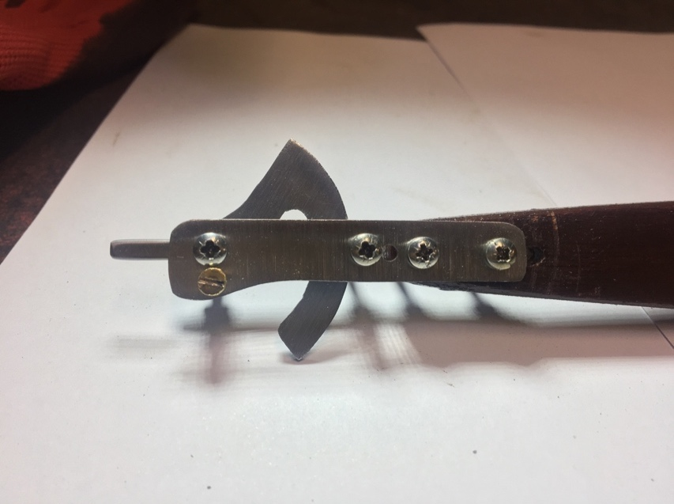pivot is in the main arm then the firing pin must be outside of the main arm which means you are always going to have some separation, however, if the pivot was not in the main arm then such an issue wouldn’t come to mind and in about thirty seconds I had finalised the new design in my amazing mind workshop.

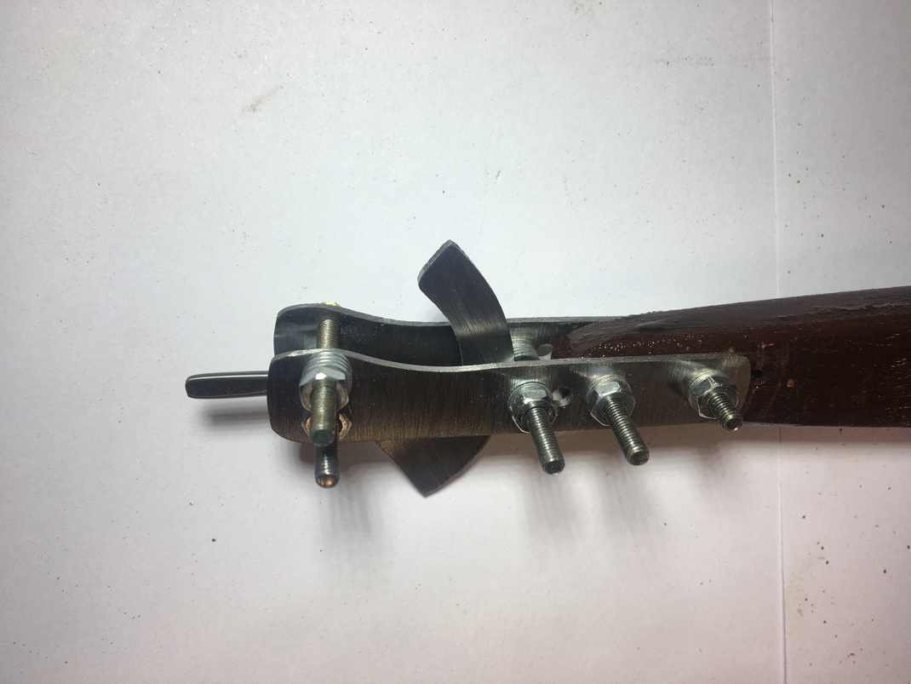All that came now was to make the thing in the realm of reality from the realm of my mind.

I measured it out very precisely to give it exactly 55° on either side which is what I around what I found to work previously with some clearance just in case.

The scythe-like design of the main piece was half the result of needing to allow the permanent sling connection holding bolt past and half a cosmetic decision I that I am utterly thrilled with the results thereof. It’s the kind of design only possible when working with metal and it strikes me as the scythe of a futuristic cyborg death.

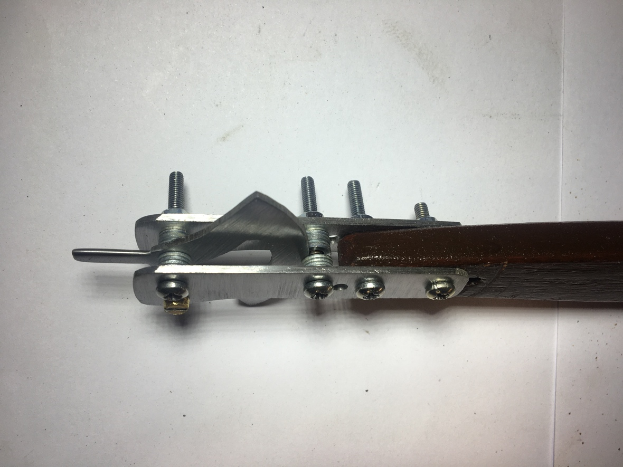An advantage of this new firing pin design is that as it is only one flat plate that moves it makes the design a lot simpler and it looks a lot cleaner in general. Another advantage of this design is that I am clamping the main piece from outside it means I don’t have to laboriously and messily carve out a slot in it. For the firing pin 3.0 I made the slots by drilling lots of holes and then connecting them with a Dremel, this is however far from the optimal method but it was the best I could come up with my tools.

As a comparison I thought it would be interesting to state the distance between the bottom of the firing pin and the firing pin assembly pivot for all of the recent firing pin assemblies:

Firing pin 3.0 separation: 2.6cm

Firing pin 3.1 separation: 1.2cm

Firing pin 4.0 separation: 0.4cm

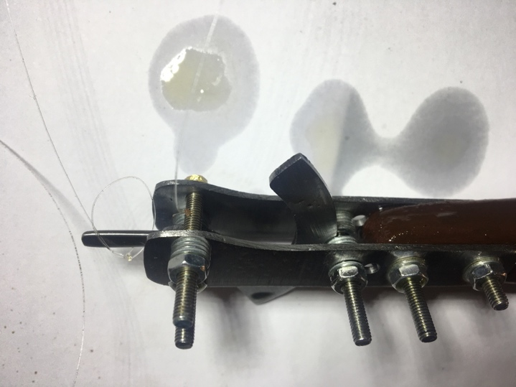As you can see for every new firing pin assembly, I have over halved the separation which should improve the stability of the dependant variables for any experiments requiring the adjustment of the firing pin angle. This is because when changing the firing pin angle that is an independent variable whereas the position of the firing pin is not supposed to be an independent but a control variable.

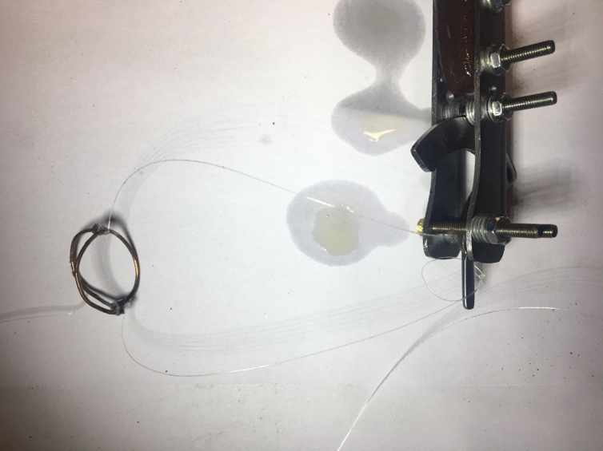The firing pin 4.0’s pivot point is outside of the main arm it means that the firing pin can be much closer to the pivot. I think that 0.4cm is very close to optimal for this as 0.15cm of that separation is half of the diameter of the M3 bolt that makes up the pivot.

My favourite improvement for this part is that I sanded all of the paint off the steel so that the assembly came out looking really clean and a massive improvement on the previous versions. It was especially easy as all the sub-parts are flat in this part. Importantly I was notified that the steel would quickly rust so I needed to coat the surface with a thin layer of oil so that no rust could form.

I also did the same for metal carriage release system parts.

# The main arm 2.6

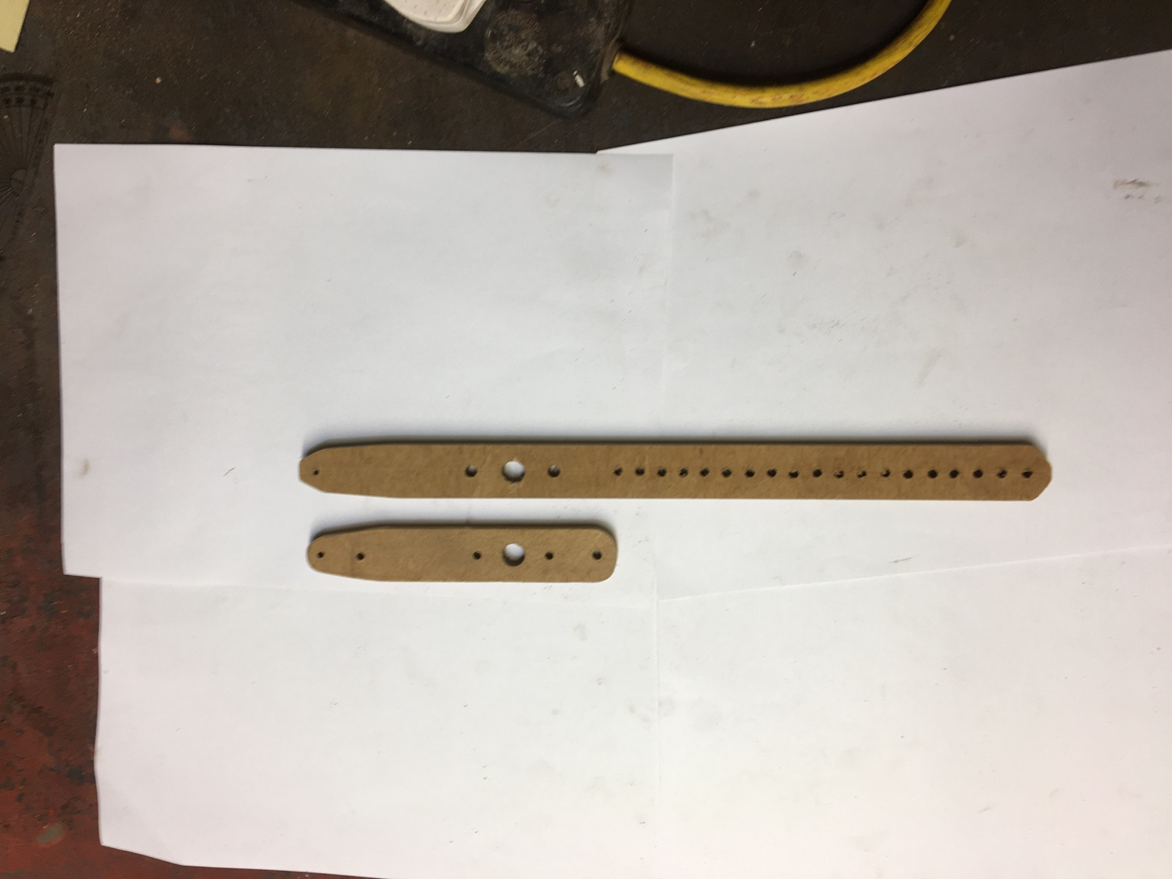The only differences from its predecessor are that it has holes all the way up too 23cm, because up until now I had forgotten the standard setups, and that I have chosen not to dye and varnish it because at the rate I am iterating parts at the moment it’s not worth the effort. I will make everything look nice and pretty when it does the job and does it well.

# The unthanked heroic hidden parts

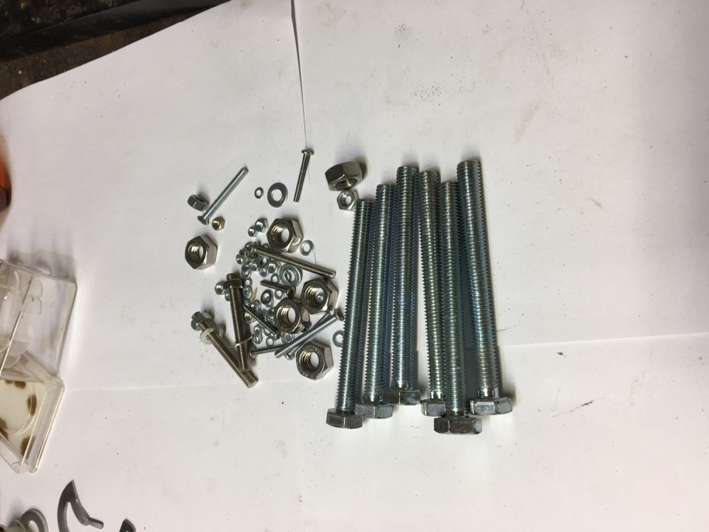When doing a mass disassembly I thought it would be interesting to show all the nut, bolts and washers used in holding my trebuchet together. I use M3’s for the intricate firing pin assemblies. I use M4’s for attaching the counterweight, attaching the modular ramps, for the secondary pivot, and for attaching the bearing housings on the smaller main arm. I use M6’s for attaching the two remaining bearing housings to the main arm and for the y-axis adjustment bolts for the carriage release mechanism 5.0. Finally I use M10’s for attaching the trebuchet to the plank through the soft wood buffers and for the x-axis of the carriage release mechanism 5.0 through the plank. The only nuts I’ve had to restock upon are some longer M4’s and some slightly longer M6’s.

I also think it’s quite interesting how I am able to spew all that up on the spot completely from memory without having to check or measure anything.

# The chord path problem

Same intro as before

# The carriage armed projectile retention problem

It was when I was analysing the footage from the failed first attempt at the second firing pin angle experiment that it became apparent that the sticky carriage problem had come back. This is likely due to the new carriage so I needed to do a lot of tweaking until the projectile could easily come out of the carriage when only supported by the fixed line. This included making the carriage less deep and the ramp on one side more prominent. I also had to file down the solder on the inside just like I had to do last time to stop the projectile getting stuck on it when going past that joint. The small inconvenience of this is that it had the knock on effect of destroying the fishing line connected at that joint, which was the loop fishing line, so I would have to retie it.

When the trebuchet is being armed the last step is to add the projectile to the carriage however since the fixed line side is always down on the firing pin assemble it means that that is also the side of the carriage that faces down at the release position. This means the side of the carriage optimised for allowing the carriage to fall out is the side down. This was a bit of an issue as it meant that the projectile would not stay in the carriage at launch.

I considered this problem when about to retie the loop line of the sling and thought if I could adjust the length of the loop line to be slightly longer that the fixed line then it would make the carriage tilt slightly at release which may allow the projectile to stay in.

The first time I tried redoing the loop sling line I measured it at 13cm but that ended up being too slightly too long so I cut it off and did another. This time I measured it at 12.5 cm but when I had finished tying it to that carriage I found it was way too long, even longer than the first. I then realized that I had measured it from the knot of the loop instead of the end of the loop like I did the first time. When I tried making another loop for the next attempt I rushed in tightening and the know just snapped due to melting from friction. When I had successfully made another loop I measured it the same as the second time but measured from the end of the loop. However when I finished tying it to the carriage to my inner sarcastic concious’s mind lack of surprise the loop line just so happened to now be almost double the length that it should have been blowing the other two attempts out of the water in terms of sheer magnitude of distance from where I wanted the loop line to be. It turns out that I had completely ignored the measurement marking I had made on the fishing line and just tied it the first place I could. Luckily I could shop this loop line off with enough spare to retie the same loop line so that’s what I did this time tieing it directly on my marking. It looked good to me so I took the firing pin assembly back to the trebuchet and fixed it back to the main arm and went to arm it with the carriage release system which is when I found from observation that the loop line being longer rotated the carriage in the wrong direction at firing position so the marble was now be encouraged to fall out at launch position. With a hearty faceplant I took off the firing pin and went back to the fishing line tying bench. This time I measured the loop line at 10cm and it looked good after tying so I went and attached the firing pin assembly back to the trebuchet and armed it. This time the carriage looked perfect at the release point with the loop line be just short enough compared to the fixed line so that the carriage was slanted at the release position.

This fixed the problem quite resolutely and I am happy with the result regardless of the number of mistakes it took get here.